

**CST3310 – Strategic Information Systems**

# (Enterprise Project) Management Case Study: BT Group (Group CST3310HE08)

|  |  |
| --- | --- |
| **Student Number** | **Student Name** |
| **M00944298** | Parmdeep Gill |
| **M00810926** | Abdullahi Mohamed |
| **M00958490** | Boluwaji Kehinde |
| **M00811809** | Shoyful Islam |
| **M00974403** | Chinoso Nwafor |
| **M00853031** | Ali Hassan |
| **M00844801** | Manitta Sunny Eappen |

**Computer Science Department**

**Faculty of Science & Technology**

**Middlesex University**

Submitted on: 17/12/2023

Table of Contents

0. Introduction 4

0.1 Introduction of your consultancy start-up 4

0.2 Presentation of each group member profile 4

0.3 Description of the selected Case Study organisation 5

1. Strategic Management Principles 6

1.1 Establishment of a robust strategic management process 6

1.2 Conduct of the sector’s competitive analysis 6

1.3 Introduction of strategic leadership approach 8

2. Information Systems Types 9

2.1 Overview of different types of information systems relevant to the organisation 9

2.2 Discussion of a suitable typology for classifying the organisation’s systems 10

2.3 Description of the organisation’s information system functions 11

3. Managing IT Projects 12

3.1 Review of the core IT project management practices 12

3.2 Creation of a project management plan 13

3.3 Identification of key work packages 14

4. Systems Development Models 15

4.1 Review of appropriate systems development models 15

4.2 Selection of the most suitable model for the organisation 15

4.3 Description of how the model will be implemented by the organisation 16

5. Digital Business Models 17

5.1 Overview of appropriate digital models for the specific sector 17

5.2 Description of an appropriate model that is in place at the organisation 18

5.3 Reflection on how the model is implemented and its impact on the organisation 18

6. Business Information Systems (ERP/CRM/SCM) 19

6.1 Review of the organisation’s Business Information Systems 19

6.2 Description of core business operations supported by these systems 19

6.3 Explanation of the infrastructure and resources required for these systems 20

7. Conclusions 21

7.1 Summary of main suggestions for the organisation 21

7.2 Identification of main constraints in applying proposed plans 21

7.3 Reflection on lessons learnt for the members of the start-up 22

Appendix A – Interview questions 23

Appendix B – Individual reflection 42

Member 1 – M00853031 Ali, Hassan 42

Member 2 – M00810926 Abdullahi, Mohamed 61

Member 3 – M00944298 Parmdeep, Gill 74

Member 4 – M00958490 Boluwaji, Kehinde 85

Member 5 – M00844801 Manitta, Sunny 95

Member 6 – M00811809 Shoyful, Islam 17

Member 7 – M00974403 Chinonso, Nwafor 17

Appendix C – Further evidence 19

References 20

# Introduction

The scope of this report is to look at the management of BTs information systems and to understand the IT projects of the organisation.

## 0.1 Introduction of your consultancy start-up

We are a group of 7 experts running a consultancy firm who are specialised in management information systems. The goal of our consultancy firm is to improve current management information systems of IT projects.

## 0.2 Presentation of each group member profile

|  |  |  |  |  |  |  |
| --- | --- | --- | --- | --- | --- | --- |
| ID | Name | Sections | VARK | MBTI | PAEI | Belbin |
| M00944298 | Parmdeep Gill | 0, 6, 7 | Visual = 2  Aural = 9  Read/Write = 7  Kinaesthetic = 4 | INTJ | Paei(15)  pAei(16)  paEi(12)  paeI(12) | Resource Investigator (10);  Teamworker (9);  Co-ordinator (9);  Plant (9);  Monitor Evaluator (11);  Shaper (10);  Implementer (8);  Complete Finisher (4);  Specialist (0) |
| M00810926 | Abdullahi Mohamed | 0, 1, 7 | Visual = 6  Aural =5  Read/Write = 3  Kinaesthetic = 2 | INTJ | Paei(9)  pAei(15)  paEi(17)  paeI(12) | Resource Investigator (13);  Teamworker (8);  Co-ordinator (17);  Plant (0);  Monitor Evaluator (12);  Shaper (1);  Implementer (18);  Complete Finisher (1);  Specialist (0) |
| M00958490 | Boluwaji Kehinde | 0, 2, 7 | Visual = 7  Aural = 11  Read/Write = 5  Kinaesthetic = 13 | ESTJ | Paei(12)  pAei(12)  paEi(15)  paeI(16) | Resource Investigator (11);  Teamworker (6);  Co-ordinator (7);  Plant (9);  Monitor Evaluator (6);  Shaper (7);  Implementer (17);  Complete Finisher (7);  Specialist (0) |
| M00811809 | Shoyful Islam | 0, 3, 7 | Kinaesthetic: 8 | ESFJ | Paei(15)  pAei(15)  paEi(12)  paeI(11) | Resource Investigator (7);  Teamworker (7);  Co-ordinator (10);  Plant (8);  Monitor Evaluator (6);  Shaper (10);  Implementer (15);  Complete Finisher (7);  Specialist (0) |
| M00974403 | Chinoso Nwafor | 0, 4, 7 | Visual = 11  Aural = 5  Read/write = 8  Kinaesthetic = 10 | ENTJ | Paei (15)  pAei (13)  paEi (13)  paeI (14) | Resource Investigator (9);  Teamworker (6);  Co-ordinator (0);  Plant (5);  Monitor Evaluator (6);  Shaper (0);  Implementer (31);  Complete Finisher (13);  Specialist (0) |
| M00853031 | Ali Hassan | 0, 5, 7 | Visual = 2  Aural = 9  Read/write = 2  Kinaesthetic = 7 | ISTJ | Paei (16)  pAei (11)  paEi (14)  paeI (14) | Resource Investigator (4);  Teamworker (9);  Co-ordinator (8);  Plant (12);  Monitor Evaluator (8);  Shaper (15);  Implementer (8);  Complete Finisher (6);  Specialist (0) |
| M00844801 | Manitta  Sunny Eappen | 0, 2, 7 | Visual =  Aural =  Read/write =  Kinaesthetic = |  | Paei ()  pAei ()  paEi ()  paeI () | Resource Investigator ();  Teamworker ();  Co-ordinator ();  Plant ();  Monitor Evaluator ();  Shaper ();  Implementer ();  Completer Finisher ();  Specialist () |

## 0.3 Description of the selected Case Study organisation

The case study we have chosen is BT. They are a British multinational telecommunications company that is the largest provider of fixed line broadband and mobile services in the UK. BT are a company that provide mobile and broadband services to over 30 million consumers and are known to be keeping the UK connected.

# Strategic Management Principles

How BT can use strategic management principles, to improve the current state of the company's values, sales, and reputation.

## 1.1 Establishment of a robust strategic management process

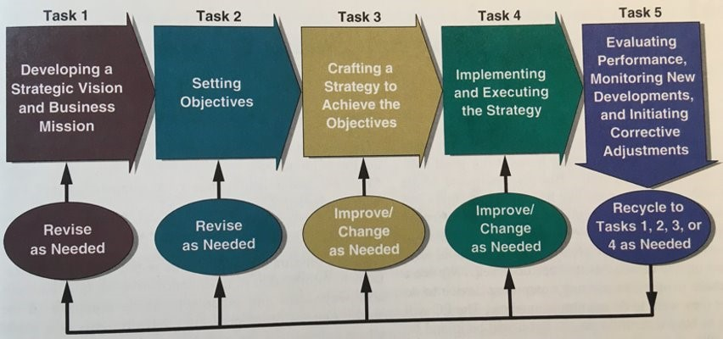

BT can use strategic management principles such as:

* The four key areas include, internal, external, formulating strategies and setting objectives. Helps in executing a process that involves any problems and provide a solution for the project.
* BT strategy in terms of mission statement is that its purpose is to connect for good for all customers and provide an excellent service to the customers.
* The vision statement for BT is to become the world most trusted connector of all devices and machine.
* BT evaluates project performances by having set weekly meetings on the progression of it and make any adjustments.

## 1.2 Conduct of the sector’s competitive analysis

To conduct customer analysis BT common method is Porters five forces. It helps to showcases strengths, identifies, and displays opportunities to expand the business and leads to a successful project.

**Porters Five Forces**

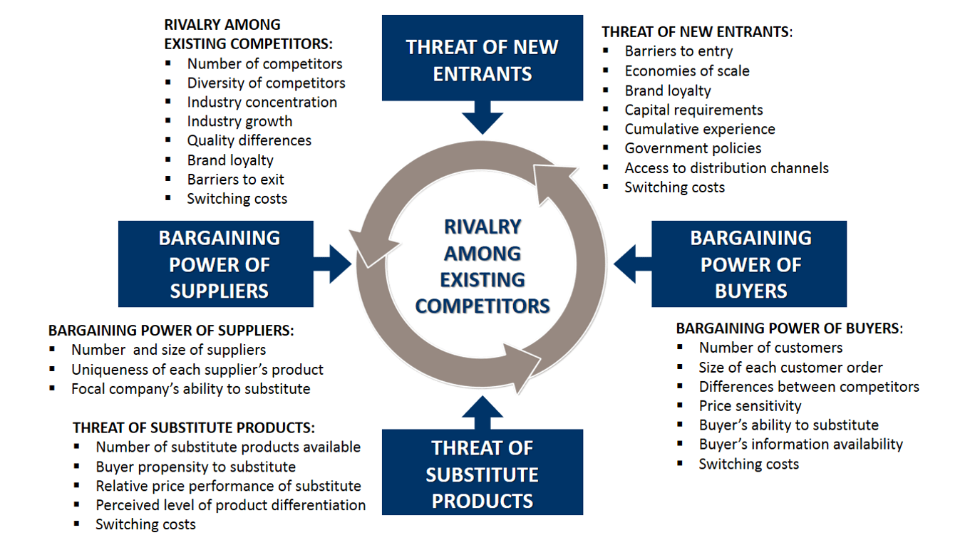

**Swot Analysis**

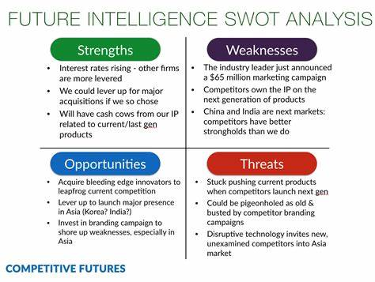

Identifies competitor analysis is dependent on the availability of work and the goals of the projects, this is because the experiences and knowledge of each group project will differ dependant on the skillset. For example, an intern from BT uses SWOT analysis to conduct competitor analysis, to simplify complex issues, builds organization strengths, and provide strategic planning.

**PESTLE**

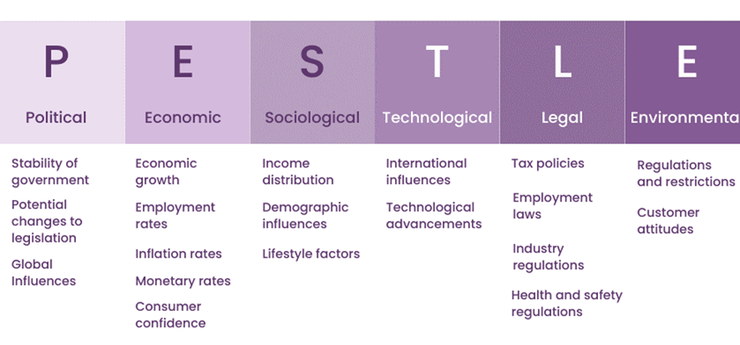It provides contextual information and has a clear business driven direction, enabling targets and determines the validity of existing products and services, for example if BT don’t have enough staff, they can use PESTLE analysis to conduct and define a solution because it focuses on the political, economic, sociological, technological, legal, and environmental analysis of the business. 

## 1.3 Introduction of strategic leadership approach

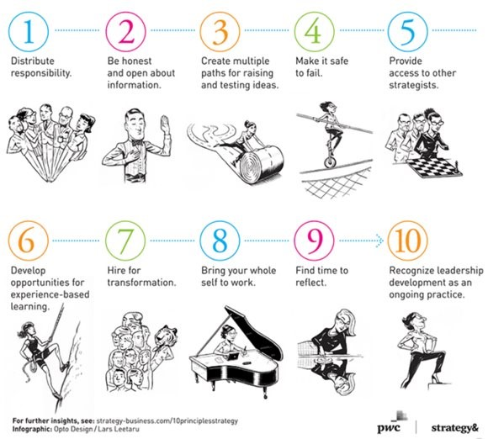Strategic leadership approach is based on building strong foundations, having a clear set of network capabilities such as subcontracting continuous tasks to ensure major project deadlines are met. The company values for all types of work are to be personal when working with any project and to make it as simple, user friendly for customers and to have a brilliant attitude whilst participating within the work. BT’s aim to lead to a bright sustainable future as a company because they prioritise customer expectations and experiences.

# Information System Types

Set of **interrelated components** that BT uses to collect, process, store, and breakdown the **information** to **support decision making.**

BT use three major dimensions which are:

a.     **Organizational:** standard operating procedures and the culture of an organization embedded within them.

b.     **Management:** supply tools and information needed by the managers to allocate, coordinate, and monitor their work, make decisions, create new products and services.

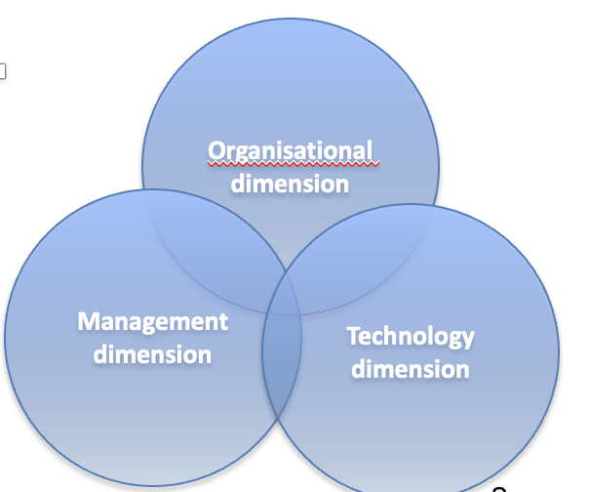c.     **Technology:** involve computer hardware/software, data management technology, networking/telecom technology

## 2.1 Overview of different types of information systems relevant to the organisation

BT need different information system to carry out various tasks some of which are:

·       Process control systems monitors the physical or industrial processes of their business (e.g., Mobile phone assembly or metal fabrication).

·       Sales and marketing systems: Helps BT's management to execute and track the efficiency of a company’s marketing functions and sales (e.g., increasing product sales, improving product quality, handling distribution networks, managing pricing, and advertising).

·       Decision Support Systems: Helps management to make well-informed decisions by gathering data from both external sources like population trends, interest rates Internal sources like manufactory, sales, and financial data.

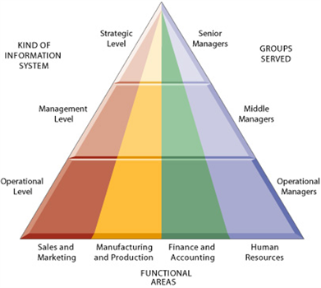·       Transaction processing systems: collects and process data produced during BT’s routine activities.

## 

## 2.2 Discussion of a suitable typology for classifying the organisation’s systems

To categorize BT systems into an appropriate typology, it is imported to comprehend the several organization levels and functional domains.

Executive support system (ESS) for Strategic Level

ESS provides BT’s high-level executives with the data they need to make long-term strategic decisions. These comprise competitive analysis, market trend analysis, and maintaining overall strategic goal - setting process.

Management Information System (MIS) for Management Level

For monitoring and controlling several areas of BT operations, Middle managers utilize these systems. These comprise financial reporting, inventory, and sales system that give reports for daily decision making.

Decision Support System (DSS) for Management Level

DSS supports both unstructured and semi structured decision making at the management level. BT may use DSS for additional administrative decisions including data analysis and what-if scenarios such as budget allocation and product planning.

Transaction Processing System (TPS) for Operational Level:

Operational Transaction Systems: TPS effectively processes daily transactions at the operational level. BT use it for system that tracks sales, controls inventory, handles procurement and supervise production procedures.

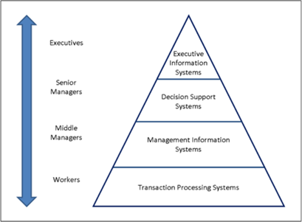

As a result of the above classifications, BT is able to organize its information systems based on how they are intended to be used and how much they support the company. This helps the Middle Managers to have the information needed for daily decision making.

## 2.3 Description of the organisation’s information system functions

Organizations can be divided into strategic management and operational levels and into four major functional areas such as:

1) Sales and marketing are important for maintaining customer relationships, creating advertisements and sales forecasting.

2) Manufacturing and production: important for quality control, supply chain and production process management. BT uses quality control software, supply chain management systems (SCM) and manufacturing execution systems (MES).

3)Financing and accounting: Financial transactions and managing accounts play an important role in the development of a company. BT’s financial systems use tools used for budgeting and enterprise resource planning software (ERP).

4) Human Resources: BT makes use of payroll software, trading and development software and human resource management systems (HRMS) to support employee development to manage HR duties including hiring and paying employees.

# Managing IT Projects

In BT the project manager follows a project management methodology. They follow a management methodology such as waterfall or agile. The IT manger in BT manages and plan the project to align with the business goals.

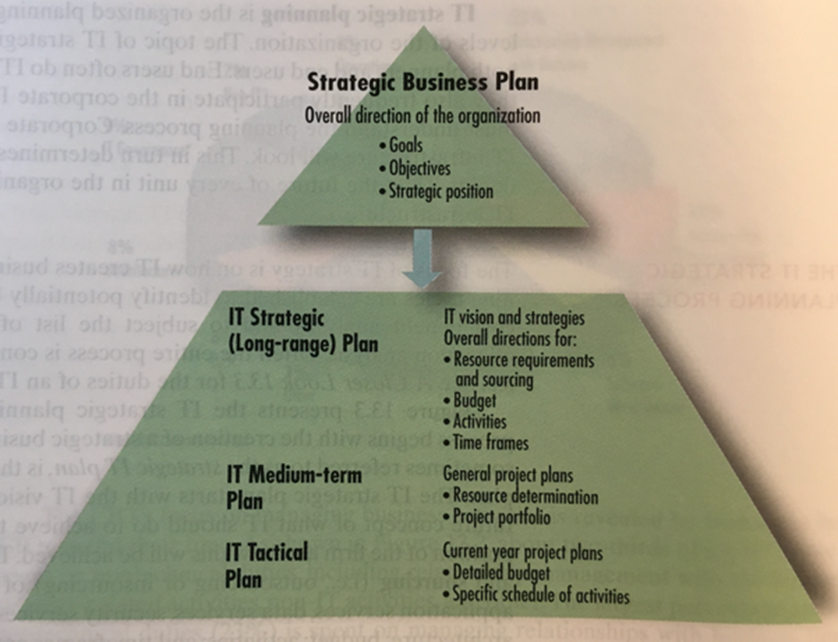

## 3.1 Review of the core IT project management practices

The review of core IT project management practices highlights key considerations for a IT project manager. Time management is critical to meeting deadlines, preventing stock loss, and maintaining customer loyalty. Cost management involves securing adequate financial support and budgeting effectively. Clear communication with BT executives, stakeholders, and employees is essential. Risk analysis is crucial to anticipate potential failures and financial losses.

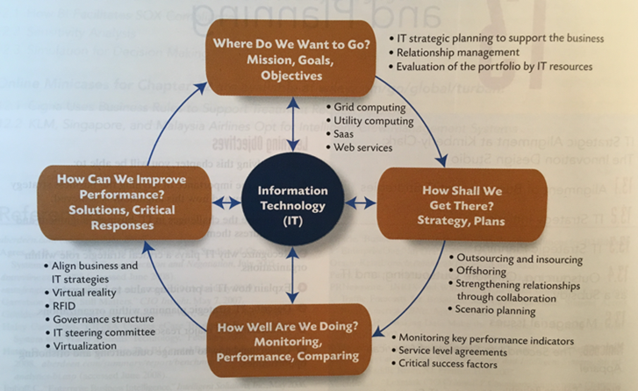

When delivering a project, the project manager should follow this performance model. It showcases how to plan the project, how to monitor the project and lastly what should be the next step for the project manager, the team and BT. Should they make improvements or change project?

## 3.2 Creation of a project management plan

BT needs a comprehensive framework for effective project planning and execution. The introduction sets the stage by outlining the project's background, objectives, scope, and resources, alignment with BT’s business goals. The subsequent sections strategically address key elements: The Structure and Organization segment establishes roles, responsibilities, and governance structures. Risk Management looks for potential risks and a strategic response to potential project risks.

Stakeholder communication is prioritised. Change Management strategy is introduced to handle project changes, ensuring transparent communication with the team/stakeholders. Budget and Cost Control strategies monitoring for effective project expense management.

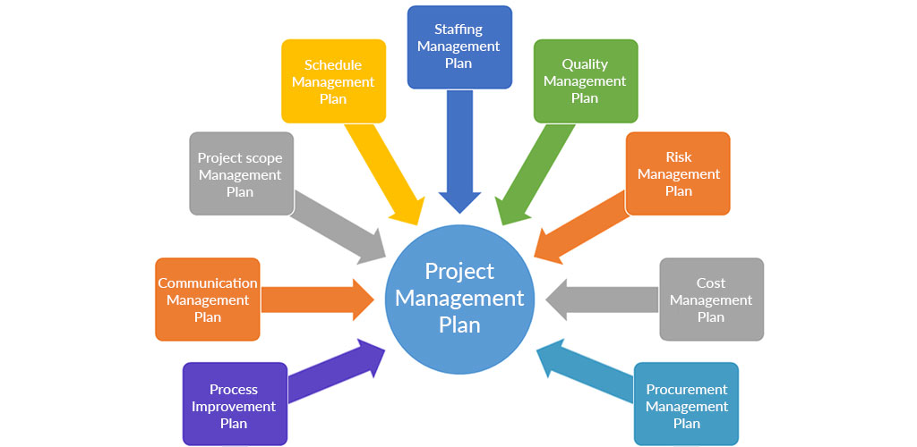

## 3.3 Identification of key work packages

Helps break down larger tasks to smaller activities. These tasks can run concurrently with each other, so the project can get done quickly rather than the whole team working on one task. System Design example:

* Create system architecture and design documentation.
* Develop wireframes or prototypes for user interfaces.
* Identify technology and infrastructure requirements.

These tasks above are broken down from the System design task, after completing these tasks it completes the system design task. This method can help an IT project in BT to be done efficiently and quicker.

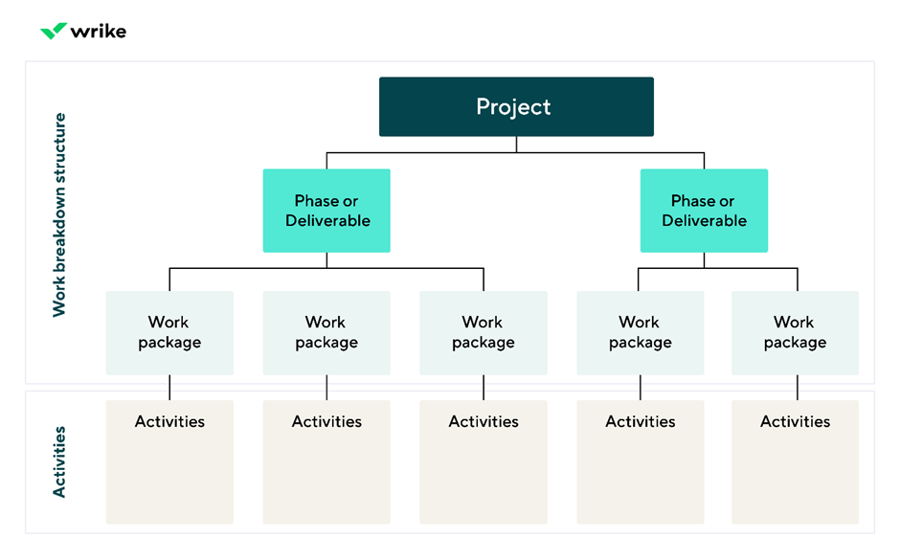

# Systems Development Models

I will go over various system development models and identify which one is most suitable for BT and explain how it can be implemented.

## 4.1 Review of appropriate systems development models

**I-P-O Model:**

Waterfall Model: Structured approach is appropriate for BT as It makes sure that projects are completed on schedule, within budget, and of excellent quality.

Agile Model: It allows BT for a rapid response to feedback and market changes, promoting adaptability and continuous improvement.

Spiral Model: Provides solid framework for project management within BT. It enables the early detection and mitigation of possible hazards throughout the project lifetime

Iterative model: Enables BT to make small incremental releases, with each iteration requiring a revisit and improvement of the product based on feedback. Each iteration takes them closer to a solution that meets their business needs and meets the expectations of their customers.

## 4.2 Selection of the most suitable model for the organisation

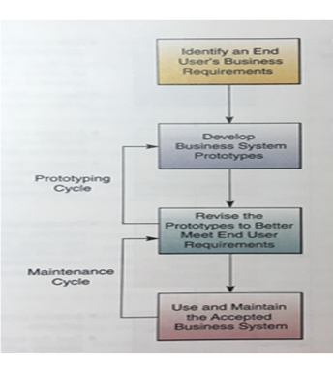The Iterative model is best suited for BT. When building a new broadband service, for example, BT could start with a basic version that includes typical functionality. This first release would be the first iteration. Customer feedback would then be collected and analysed after the release. This feedback, which may include requests for new features to ideas for enhancing user experience, will then be integrated into the service's next iteration.

This incremental improvement method enables BT to modify the service in response to user feedback, ensuring that the final product is closely aligned with their customer needs.

**4.3 Description of how the model will be implemented by the organisation Prototype Development Process**

Prototype Development Process: An Iterative approach for BT:

1. **Formation of Teams:** Cross-functional teams are built, which include both users and developers.

2. **Schematic Design:** The team builds an initial schematic design together, focusing on characteristics like flexibility, adaptability, and responsiveness to changing needs.

3. **Prototype:** This group collaborates to create an early prototype schematic design. Using prototyping tools, the schematic is then transformed into a simple point-and-click prototype.

4. **User Feedback and Iteration:** The team shows the prototype to a select group of users and seeks feedback.

5. **Consultation with IT Consultants:** To solve potential technical challenges, BT works with IT professionals. This, together with their connections with over 200 partner organisations as part of their Collaborative Research Programme (BT, Research and development), assures technological feasibility and the achievement of current objectives.

6. **Conversion into Finished Application:** After user validation, the prototype is transformed into a final application.

7. **User Review and Acceptance:** In iterative cycles, users examine and sign off on their adoption of the new business system.

8. **Installation on Network Servers:** Following user approval, the iterative process guarantees that the new business software is installed on network servers.

# Digital Business Models

Discussing the strategic plan that BT uses to create and deliver value using digital technology.

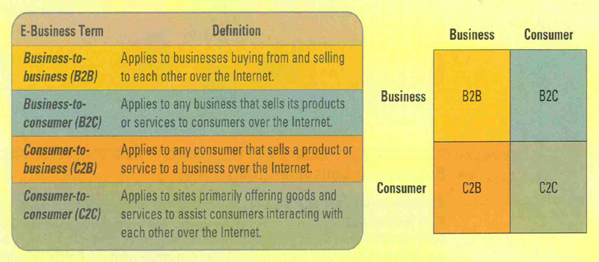

## 5.1 Overview of appropriate digital models for the specific sector

BT falls under Business-to-consumer as customers can buy their products and services online from BT. The website must be user-friendly to attract customers. They collect data (within data regulations) from their website for management information systems to make informed decisions.

* **Data monetisation model** – to make targeted offers using insights from data collected. Source of additional revenue by selling the data to businesses and manage customer trust.
* **Manager Services model** – corporate side to provide other businesses with strategic advice on aspects such as communication, IT, security, and digital transformation needs.
* **Subscription model** – most used model in the telecommunications industry. BT has customers on fixed contracts paying a recurring fee to have access to their products and services.

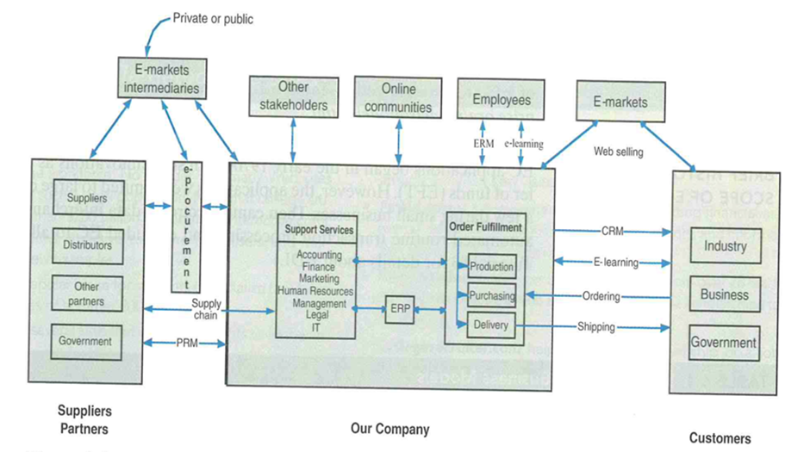

## 

## 5.2 Description of an appropriate model that is in place at the organisation

BT mostly uses a subscription model whilst using E-commerce model to drive sales online. They will be able to retain customers as they will be able to provide them with reasonable prices especially when considering the customer may be looking to change their products such as mobile phone or their internet package frequently.

The benefits are that they have been able to predict their revenue streams, sustainable growth, retain customers and can predict the value of each customer thus providing better products and services to achieve high levels of customer satisfaction.

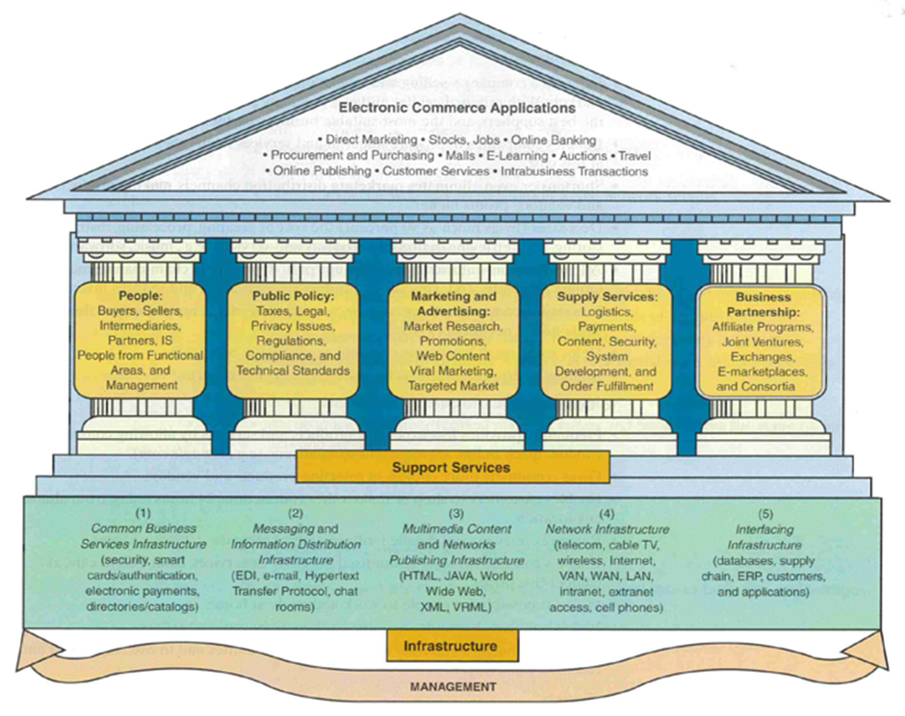

## 

## 5.3 Reflection on how the model is implemented and its impact on the organisation

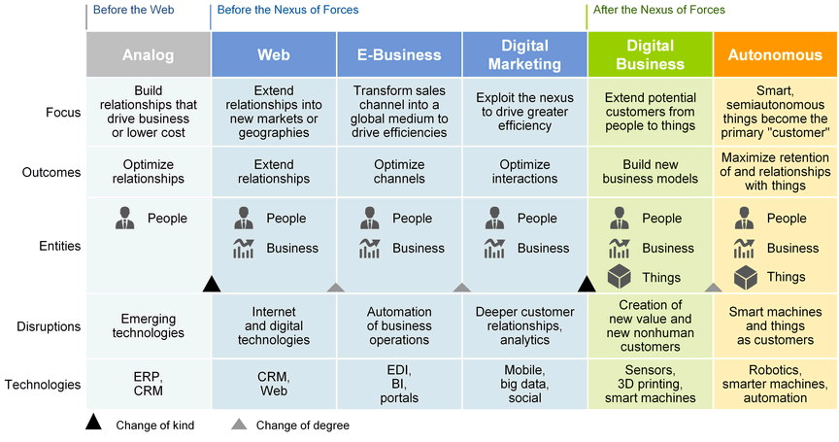BT are actively looking to use as many businesses models as possible and new options available to makes sure they are ahead of their industry competitors. They are looking to move from a subscription model which is predominantly used in their industry and move towards an ecosystem model so that they have more products and services to offer, and customers don’t have to go to different businesses to get what they need as BT is able to provide it in a bundle. The current subscription model makes it difficult to manage churn as in the industry all the competitors can provide a product or service to the customers where the customer will be unable to identify uniqueness between them. Customers will be looking for the cheapest price offered thus cutting the volume of revenue for BT especially in the long term if it continues to drop which shows the importance of adapting and moving towards the ecosystem model and benefiting from different business models within their operations for example skills, assets, and capabilities.

# Business Information Systems (ERP/CRM/SCM)

Reviewing information systems in BT with a focus on ERP, CRM and SCM.

**6.1 Review of the organisation’s Business Information Systems**

ERP is a software system that will take care of your companies' business, such as finance, Human Resources, services and many more. BT’s ERP systems will be known as the integration point where the ERP will bring together the different business processes and functions across BT such as HR, supply chain and marketing.

CRM stands for customer relationship management and BT use it to manage the interactions with their company and its customers. The system allows to build strong customer relationships so BT can increase its sales by providing a better customer service which will lead to an increase in profits and revenue. This is a software that’s utilised by BT and plays a vital role in facilitating a strong relationship between BT and its partners.

BT use Supply Chain Management (SCM), and this is the process of managing the flow of goods and services to and from your business. An effective SCM will allow you to streamline your activities and eliminate waste and gain a competitive advantage within your industry. BT will not do a lot of production however the SCM will be used for the distribution aspect as BT will send hundreds of thousands of devices monthly so an efficient SCM will be very important.

BT will use business information systems in a variety of ways to provide them with benefits such as marketing, revenue increase etc.

Marketing information system is a system that helps track your projected sales, handles distribution, and uses the most effective marketing methods which is why BT are known to have the best marketing strategies.

Database information system is a system that BT uses, for example they can use it to handle customer feedback and reviews which allows BT to keep an eye on what customers are looking for.

## 6.2 Description of core business operations supported by these systems

ERP systems core components for business operations will include things like accounting and finance, Human resource and Production and materials management. Accounting and finance it will examine things like cost control, budgeting, and expense management.

CRM will support customer service operations and marketing as the whole purpose of this system is to support customer interaction and make BT easier to do business with.

SCM can support BT with order/inventory tracking can all be monitored with the SCM and can also help establish objectives and policies.

## 6.3 Explanation of the infrastructure and resources required for these systems

BT have a combination of private and public cloud services. BTs partnership with Amazon web services provides some of the resources. BT subcontract with partners therefore many other resources are provided to develop and manage these systems. Niche suppliers will be used for resources when BT are looking to buy a product, license or manage services.

# Conclusions

We were responsible in providing BT methods to improve the information systems and management of IT projects. This includes suggestions for the current strategic management principles, types of information system, IT projects, system development models, business digital models and business information systems and each section has been assessed and overviewed for BT to implement.

## 7.1 Summary of main suggestions for the organisation

BT should have a set competitor analysis such as PESTLE analysis to become the world trusted connector. BT would be advised to involve customers by regularly mailing and live to their slogan personal, brilliant, and friendly because it helps build a sustainable future.

BT can boost their information systems by investing in advance data analytics, strengthening cybersecurity, and adopting cloud tech. This leads to smarter decisions, enhanced data protection, improved scalability, and customer experiences.

BT should have an introduction to set the stage and after that they are able to address key elements within the project. Key work packages allow the breakdown of larger tasks to smaller activities to run concurrently. Improves efficiency and allows for project deadlines to be met.

BT should adopt the Iterative model for system development. This approach aligns well the development of new broadband services as the emphasis is on user feedback.

BT should move towards an ecosystem model; they will be able to provide more services and products to their customers hence providing them with a competitive advantage.

BT should look at implementing new business information systems to allow them to look for new ways of operating efficiently and improve the overall productivity.

## 7.2 Identification of main constraints in applying proposed plans

BT don’t have designated job role that are familiar with all three-competitor analysis. This delays meeting project time and senior management are skilled in all 3 solely which leaves employees without the knowledge. So having 30minute weekly upskilling sessions to improve the scope and severity of project.

While investing in advanced data analytics, cybersecurity, and cloud tech can bring benefits, BT may face challenges like initial costs, systems integration, employee resistance, and data security. But with proper planning these challenges can be overcome leading to improved info systems for BT

Good communication and teamwork skills to meet deadlines as this proposed plan will require individuals to take responsibility for their activities.

BT’s resistance to change as iterative model requires shift in viewpoint and approach and this will require additional time and resources to implement successfully.

Required a major shift from their expertise in the subscription model. Therefor require changes throughout the organisation to make sure they provide the same customer experience.

During the implementation of these new business information systems some workers may not have the knowledge and skills utilise new information systems so leads to problems such as more cost required for employees to learn the skills.

## 7.3 Reflection on lessons learnt for the members of the start-up

A total word count of 3000 caused a problem for us as every group member worked on their own sections and certain sections went over the word count, so we had to cut some parts. For future projects we will clearly say how much content should be in each individual section.

Communication and having regular contact with each other are necessary so for our next project we must do these things to be as efficient as possible and to produce the best results. Deadlines that had been set, so we had to make sure everyone was on track with their work and going to meet the deadline. Next time by creating small deadlines for each topic before the final one so the work is done over a period time.

# Appendix A – Interview questions

A list of at least 20 questions for an interview with a strategic manager of the organisation:

**Interview Questions For BT**

Before we start would you like this interview to be recorded and is there anything else you would like us to be aware of before proceeding on with the questions?

**Section 1 – Strategic Management Principles**

* What is BT's current strategic management process, and how does it enable the company to adapt to changes within the industry?
* How does BT analyse its competitors in the telecommunications sector? Can you provide an overview of the methods or models, such as Porter's Five Forces, used for competitive analysis?
* What strategic leadership approaches has BT implemented to encourage innovation and empower employees within the organization?
* What are the current mission statements and vision statements of BT Group?

**Section 2 – Information System Types**

* What are the primary information systems used by BT for managing its telecommunications services and infrastructure?
* How does BT’s customer relationship management (CRM) system help the company interact with its customers and provide services more effectively?
* Can you provide an overview of the cybersecurity measures and information security systems in place at BT to protect its network and customer data?

**Section 3 – Managing IT Projects**

* How are IT projects managed in BT?
* What project management practices does an IT project manager adhere too in BT?
* Has there ever been an IT project that was seen as a risk and had to be cancelled?

**Section 4 – System Development Models**

* As a Senior Manager in Programme Delivery, could you share some examples of the system development models that you have used in your projects at BT Group to plan, create, and manage information systems?
* In your role as a Senior Manager in Programme Delivery at BT Group, which system development model have you found to be the most effective for planning, creating, and managing information systems in your specific projects? Could you share the reasons behind this preference?
* Could you share some of the key factors that BT Group considers when implementing a new software system? How do these factors influence the decision-making process related to software development and deployment in your specific projects?

**Section 5 – Digital Business Models**

* What digital business models are used in the communication services Industry and which digital models are used by BT?
* What is the most used digital business model and how is it used by BT?
* Reflecting on the most used digital business model chosen what impact has it had on BT?
* Are there any digital business models that you wish to change or add in the near future?

Ecosystem model and their aim is to not just get customers to buy the products/services but to also use the ecosystem by using bundles and moving away from the stereotype of BT Group being just a mobile and broadband company. They will look to use their expertise from decades in mobile and broadband however they will look to have more products and services available for new and existing customers.

**Section 6 – Business Information Systems**

* What types of information systems do you use (ERP/CRM/SCM)?
* What are the core business operations supported by these systems?
* What is the infrastructure and resources required for these systems?

**Audio Transcript**

00:06 – Abdullahi

My name is Abdulahi, I'll start off with my section of the interview. The first question I want to ask is what is the strategy management process and how does it enable the company to adapt to change within the industry?

00:27 - Jakob

Sorry, I'll tell you, there's a lot of... I'll call you this. I don't know if I can be of service next week or not. Alright, can... Okay, is it better now? Try again. Alright, the first question I want to ask is... It's not better. Oh, my God. I think echo is coming through your line, I think. Thank you. Everyone needs to know your stuff.

00:57 - Abdullahi

Right, try again. The first question I want to ask is, do BT use strategy management processes? And how does it enable the company to adapt to change within the industry?

01:10 - Jakob

Yeah, so BT definitely does use strategic management processes. And I'd say that they evolve over time. So they evolve over time really based on changes in our

01:27- - Jakob

business environment in our leadership and in industry dynamics. So what's changing out in the industry? So yes, for sure we use them. I guess in terms of how it enables us, so we probably look at, I'd say probably four key areas. So we spend a lot of time doing internal and external assessment of our own strengths and weaknesses and strengths and weaknesses of competitors. We spend a lot of time.

01:53-- Jakob

looking at what our strategy should be, formulating that strategy and setting objectives to get to it. I mean, I guess a key role that I play at BT is executing on those outcomes. So once we kind of know what we want to do and know what we want to deliver, we kind of align the organisation's structure, processes, resources, we deliver the IT that gets us to those chosen strategies. And then once we've delivered stuff, once we've come out the other side of our strategic management,

02:23- Jakob

execution we put in place and we use these key performance indicators these operational key indicators to get really clear about if what we've done is working or not so yeah absolutely we use them absolutely they're critical to the way that we that we set out to run the business.

02.30 - Abdullahi

 What internal and external factors do you assess?

02:51 - Jakob

it's probably a bit of a blend of our own company's resources and capabilities and our own core competencies, and the same kind of factors for external, you know, for our competitors. And we do a pretty thorough analysis of the external environment. So it's not just a direct competitor analysis, we'll look at the economic conditions, what technological trends we've got, and, and where regulation is moving, you know, it's a heavily regulated industry, Telco and UK.

03:20 - Abdullahi

The second question I want to ask is, do BT use competitor analysis, such as Porter's five forces or any other sort of competitive analysis done on competitors?

03.30- Jakob

 Yeah, I mean, we do. And I guess I'd say we generally use a kind of blend of some common methods and models and that includes Porter's five forces for doing competitive analysis in the telco industry. I think it

03:48 - Jakob

tends to use in larger Telcos a bit more ad hoc and based on experience and knowledge of what the team knows about.

04:00 - Abdullahi

 Are there any particular main models you prefer or you use?

04:15 - Jakob

I wouldn't say, I mean we definitely kind of get the principles and we definitely do use porter's five forces but I think really it depends on what our goals are, what the dynamics are in industries and what the availability of the data is. And obviously our competitors make it quite difficult for us to really get a hold of all of the data we might want about what they're up to.

04:20 – Abdullahi

The third question I want to ask now is, do you have any current mission statements and vision statements at BT or are its long-term goals you focus on or short-term?

04:44 - Jakob

Yeah, so we definitely do, so our purpose at BT is that we connect for good. So that's why we exist. We're existing to provide these connections. Our ambition is to be the world's most trusted connector of people, devices, and machines. So that's kind of who we're trying to become. Our values are personal, simple, brilliant. And I could tell you a bit more about those, but really that's what guides how we set out to do our work. It's...

05:14 - Jakob

trying to always be personal, always be simple, and always be brilliant. And then if I think about our strategy, which is a little bit of a step beyond the question you asked, but if I think about our strategy when I think beyond our mission statements, it's freaky things. So, it's building the strongest foundations, having this really clear set of network capabilities. It's creating standby customer experiences. That's the space I probably operate in the most in the group. And then leading the way to a bright sustainable future. So, it's those three things that kind of guide us on growing value for all of our stakeholders and ultimately shareholders.

05:42 – Abdullahi

With the second point you made there, you answered my final question pretty much. So that's fine. Yeah. I'm going to pass over section two to Kenny. Thanks for the answers.

05:50 - Jakob

Thank you.

06:11 - Bolu Kehinde

Good afternoon. My name is Bolu Kehinde and I'll be asking questions about the information systems used by BT.

06:52 - Bolu Kehinde

So I just want to ask the first question: what are the primary information systems used by BT for managing its telecommunication services and infrastructure? 

07:00 - Jakob

Sure, so I mean, BT is really, really vast. And to do that or deliver on that level of vastness in all of the stuff that we do, we've got a very, very vast estate of IT applications and network functions.

07:22 - Jakob

And we're on a really radical simplification modernization program to reduce the number of applications that we have. But even in our end state, even in the place we're trying to get to, we'd have probably 250 IT applications that run the core of our IT business. So, you know, we're on this huge internal transformation, but there's no simple answer to that question. I guess what I should say is broadly Intelcos.

07:52 - Jakob

applications across IT or information systems across IT and network are split into two key categories. So there's business support systems, BSS, that's primarily the space I operate in, that's our kind of IT applications and that's got the channels in our product catalogues, our order management capabilities, our CRM capabilities and then on the network side we

08:21 - Jakob

our operational support systems, which is our network inventory management, our fault management, the kind of IT that runs the masts and cables in the ground. So it's a huge estate, which has got a very, very diverse set of applications in it.

08:39 - Bolu kehinde

Thank you, About CRM I wanted to ask how BT's customer relationship management systems help the company to interact with customers and provide services more effectively?

08:45 - Jakob

Yeah, of course. I mean, BT at the moment, in all telcos, so in our history, a CRM is this kind of big

09:08 - Jakob

monolithic central IT system that's got everything you need to know about a customer in it, all the data you need to know about a customer in it. And broadly we're moving away from that model to a much more modularized architecture. So each bit of our IT has got a set of data in it for a customer. But I mean, if I look at what we do on customer relationship management, I mean, we just launched on the 20th of October, the new EE, we had a

09:37 - Jakob

really big event to launch that and as part of that we launched a new EEID this is in the press you can read more about this over there but that was a it's a rethink of a traditional CRM system but it but it still has the same principle right it it brings together all of our customers interactions information into one place so that we're centred around them rather than their products and I mean the launch of the brand and the launch of of the ID is uh

10:06 - Jakob

shift towards what we call kind of platform services. So moving away from traditional telecoms, BTC and EE are primarily seen as companies that provide broadband and mobile services. We're trying to get beyond that. And I guess, when we think about what we might do with our CRM systems in the future, centred around the new EEID, it's all about building on those foundations of loads of mobile and broadband leadership, but trying to build out platform services that go beyond that.

10:38 - Bolu Kehinde

Is there a specific CRM strategy? And how often do you update if there is?

10:40 - Jakob

So, yeah, I mean, our specific CRM strategy is to move to this modularized architecture that I talk about, where we have kind of custom details, name address details in one application. And we have, we have kind of a customer's asset holdings, the products and services they have with us somewhere else. And then that's bound together around this new EEID that I spoke about. So our core strategy is around this modularization of what we have on Sierra. I think in terms of how often we update that strategy, it's on a needs basis. We've had our current implementation, if I think about our consumer mobile business for 25 plus years, the IT and...

11:35 - Jakob

The core CRM that's there has been with us for 25 plus years. So it's on a needs basis. And I think the move we're trying to make now, or the transformation we're undertaking now, should see us through the next five to 10 years. But the industry changes pretty rapidly, and it might be that we find something out, or we see a need to make a change sooner than that.

12:00 - Bolu Kehinde

Okay. Thank you very much. I'll be passing to my colleague, Manita. Cool. Thank you.

12:08 - Manitta

Hi, I'm Manitta and I've got a question for you. So it's about information systems as well. Can you provide an overview of the cyber security measures that in place at BT to like protect its network and then customer data?

12:12 - Jakob

 Yeah, I mean, I've tried to. So I guess you'll appreciate this is super sensitive information. So, you know, BT not only has got, you know,

12:36 - Jakob

most of the country in one way or another on its platforms. You know, we've 27 million mobile customers, we've 15 to 20 million households in the UK. So not only have we got a vast consumer business, there's an awful lot of very critical infrastructure for the country in BT. So BT manages a lot of the security for...

13:03 - Jakob

that you might think is innocuous like traffic lights in London, but ultimately it's those types of IT that if they were compromised in some way or another would be enormously disruptive to day to day life and would be a significant impact on people. So I'll try and I guess, you know, appreciating this quite sensitive information and I guess importantly that our cyber security

13:30 - Jakob

they change all of the time because the threat is always changing from both individuals, from groups, from state sponsored attacks, and the threat is always, always changing. And we've got dedicated teams at BT that look after both cyber and physical security of our data and our core infrastructure. And beyond that, you know, everybody in our organisation goes through regular security awareness training. So yeah, if we're talking in general terms,

13:59 - Jakob

We're pretty comprehensive. And I don't know, let alone could share exactly all of the things that we do to protect data and our network. But I think it's the stuff you'd expect. It is firewalls, intrusion detection, encryption, access control authentication, network segmentation, vulnerability management. And then of course, when things go wrong and they do, it's incident response and threat intelligence and being able to proactively and reactively

14:28 - Jakob

respond to the things that go wrong. So yeah, difficult to answer, but I think we're kind of pretty comprehensive in our approach across both cybersecurity and information security.

14:44 Mannita

Sure. This concludes the questions in section two and we'll now move to section three.

14:48 - Jakob

Awesome. Thank you.

14:52 - Shoyful

Hi Jakob,  My first question is how are IT projects managed in BT?

15:22 - Jakob

So you're right, you're right into the stuff that I do now, I guess, so that this is really where I spend my day today. So I mean, maybe if we talk a little bit about the approaches we use or the kind of principles that we might use to deliver some of the change. So we use a kind of blend of what we call waterfall and agile delivery practices and broadly, if you wanted to kind of read more about what each of those might be, broadly our waterfall approach aligns to printstoo and broadly our agile approach aligns to safety. So printstoo is a pretty widely used project management methodology and it gives a structured framework for planning, execution, and monitoring and it

15:49 - Jakob

We divide projects into manageable stages. But you have to get through the gate. You have to, at each stage, have met the criteria of the stage before. So it's great for on time, great for budget. You get high quality. It's not always quick. And then the shift we're making, or the move that we're making, is much more towards scaled agile. And that's a more agile project management technique.

16:17 - Jakob

And importantly a software engineering and product development framework. So it allows much larger organisations like BT to implement agile as a software engineering practice and lean practices at scales. And it still gives you the structure, it still gives you the collaboration and it still gets you value, but it's often quicker to market and more iterative. So yeah, I think in summary, it's a blend of

16:46 - Jakob

Waterfall prints to type delivery and agile, scaled agile framework aligned type delivery. And both of those end up with some demand resulting in an outcome back to customers and colleagues.

17:00 - Shoyful

Thank you. My next question is, has there ever been an IT project that was seen as a risk and had to be cancelled?

17:12 - Jakob

Yeah, absolutely. I think you know, we make decisions every day about projects and programs based on their merit on any given day. So, absolutely, we do cancel projects and programs regularly, you know, more often than perhaps we'd like. But I think, particularly when you think about that scaled agile framework, that's the point of it, you should be able to learn fast, make mistakes, cancel projects. And again, I guess another

17:42 - Jakob

A great piece of reading is our kind of dedicated innovation unit. So we've got a dedicated team in BT Digital called etc. BTC. And that dedicated team is all about exploring new ideas and technologies, effectively creating a little startup mentality within BT. It's the exciting place to work, I think. And, you know, that unit starts and cancels IT projects all of the time.

18:10 - Jakob

That's what they exist to do. They exist to find an idea, experiment with an idea. You might spend several hundred thousands of pounds, even more on understanding the viability of an idea. But when you understand what it's gonna take to make it fit for customers and colleagues, you might decide it's not something you can pursue anymore. So, for sure, all the time.

18:30 - Shoyful

Thank you, my section is done. I'm gonna hand it over to Chinonso.

18:40

* **Chinonso**: Hello, my name is Chinonso So. And my question will be centered around system development models that are implemented in BT Group. So, Felipe, you have already covered the first question I had with him already. So I'll proceed to the second and third question. So which system development models have you found to be the most effective? For planning, creating, and managing information systems in your specific projects.

19:08

* **Senior Manager:** : So I think broadly we are moving to, and I think personally I find most effective an iterative delivery that is as closely as possible aligned with SAFe (Scaled Agile Framework), as closely as possibly aligned with a Scaled-AGILE framework. And I think when I say an iterative delivery, I mean, you know, the development occurs through small incremental releases, each iteration of that delivery, each iteration of the thing that you build involves you revisiting and improving the product based on feedback.

19:43

* **Senior Manager:** : So you get that continuous improvement and flexibility to move the team in the direction that the feedback is suggesting that you should. So I think probably, you know, that the most effective is is an iterative delivery model that is aligned to SAFe (Scaled Agile Framework).. And I think probably, you know, the reason for that is.

20:10

* **Senior Manager:** : It's, as I've just described, flexible and adaptable. It's much easier to manage risk than waterfall or kind of scramble kanban, some of the other key agile approaches. I guess most importantly, it lets you learn and fail faster. So if you're gonna not be successful, you find out so much earlier on in the process. You find out in month one, two, three, not in month 12.

20:39

* **Senior Manager:** : which means you nearly always get a faster time to market. So yeah, I think for me, the iterative aligned to SAFe (Scaled Agile Framework). is probably most effective, but it will always depend, you know, it will always depend what objective you're trying to set out to deliver, and it will always depend on the risk appetite of the organization. So sometimes you want to get something into the market really soon. Other times, it's important to be the best.

21:08

* **Senior Manager:** : And I guess you see that often with kind of the way that Apple approaches some of the development on their iPhone. Sometimes it's really important to be first to market, but most of the time Apple may come a year to maybe even longer behind an Android equivalent. But the quality will have been so much better that it would have been worth that time. So I think it always depends but it's iterative I like to say. Oh, that's good. Thanks.

21:37

* **Chinonso**: So my next question is, can you share some of the key factors that BT Group considers when implementing a new system software system? I mean,

21:51

* **Senior Manager:** : Yeah, I say there's probably three. There's many, there's many, many, many of them. But I think if we were to put in a new software system and we do that quite regularly, especially when you think about the transformation I described earlier, there's probably three key, probably three key factors to consider.

22:20

* **Senior Manager:** : So the first is, you know, what is the business problem? What are the business requirements? So whatever we're gonna build on a software system has to align with business need, our business objective, that's crucial otherwise we may build the wrong thing. So it's got to address specific challenges, it's got to improve efficiency, it's got to enable new capabilities.

22:51

* **Senior Manager:** : I think probably the second key factor is the cost of ownership and you know while I've talked maybe about spending several hundreds of thousands of pounds on fair projects, equally the kind of cost control culture at BT is quite high compared to other organizations.

23:21

* **Senior Manager:** : Evaluating the total cost of ownership of that new software system across licensing, maintenance, support costs, is essential. Because ultimately, if you're going to bring in a new application, you've got to be confident that in the long term, the benefits outweigh both the initial and ongoing expenses of that system. If it's only going to make the company a million pounds, you're not going to spend five, ten, twenty million pounds on it over five or ten years.

23:50

* **Senior Manager:** : And then I guess the kind of third key factor, and this is something BT has been quite bad at until the last couple of years, is kind of flexibility and adaptability. So we've been very good at picking software that aligns to the business. We've been very good at picking software that is competitive and efficient. It's not always been most flexible and adaptable.

24:20

* **Senior Manager:** : So I think this shift towards much more flexible, much more adaptable. Software systems that can enable us to move with agility and build new products and services and evolve with technological enhancements is another absolutely key factor for us.
* **Chinonso:** Okay, thank you for your response. I'll be passing on to Hassan now.
* **Senior Manager:** Awesome, thank you.

24:18 - Ali

Hi Jakob, thank you for taking time out to answer a few questions for me. My first question is, what digital models are used in the communication services industry and which digital models are specifically used by BT?

24:41 - Jakob

Yeah, I mean, it's a great and really interesting question. And BT is going on a real shift here at the moment. So, I mean, as an overall group, we stretch across nearly every single digital business model that you can think of. You know, we monetize the skills, assets, capabilities of our organisation, wherever feasibly possible. And, you know, we're looking for new opportunities to find more business models every day. So, you know, I think the big ones for us are.

25:12 - Jakob

subscription-based models. You know, I think, you know, most of you will have a mobile phone and most of you will recognise the kind of EE consumer-type subscription-based model that we have. I think data monetisation is increasingly important to us. Providing managed services is very important in our corporate sector. Increasingly, BT wants to move, or sorry, EE consumer more importantly, wants to move away from a subscription-based model.

25:41 - Jakob

and more towards an ecosystem model. So yeah, I think we go across all, I mean, at the moment, right now in 2023, subscription based models are very common in the industry and very common in BTA. You know, ecosystems are probably our future.

26:00 - Ali

Okay, so my second question was going to be what is the most used business model  by BT as you said, that's a subscription model.

26:09 - Jakob

Yeah, I guess. It's a very simple concept, right? It's, you know, customers pay a recurring fee normally monthly for access to communication services. So it's the one that has held us. I think, you know, if I think about the new EE launch I talked about earlier that we did last month, that is this definite shift into the ecosystem model. So, you know, in three, four, five years, the answer to the question would hopefully be ecosystem. And that's this kind of ecosystem of interconnected services and trying to get customers

26:39 - Jakob

not necessarily always buy, but use multiple services within our same platform. So, you know, bundled in partnerships with other providers, the full lot. So yeah, I probably did answer the question, but I think it's important to see that shift we're gonna go through in the next few years. Yeah.

26:56 - Ali

So if you were to reflect on the subscription model at the moment, would you say that's helped BT against its competitors or anything just in general in the industry?

27:08 - Jakob

Yeah, I mean, broadly, we're aligned broadly if you think about it and again, maybe if we use the example of consumer mobile and you think about the pattern between EE and Vodafone and three and the kind of other MNOs across the business across the country. Broadly, we're all aligned to subscription based business models. I mean, you know, the benefits to us are that revenue is fairly predictable.

27:36 - Jakob

You can grow and have a large organisation because you know what you're going to get from customers every month. It's easier to retain customers. You usually get an increased customer lifetime value, so you can very easily predict, you know, how much value you're going to get from a customer. I think that, you know, the downside of a subscription based model and the reason we're moving away from it is it's quite difficult to manage.

28:05 - Jakob

Most customers don't really see a difference between EE or Vodafone or O2. And where they do, it's probably quite a local problem. So, I don't get service at someone's house or,

28:27 - Jakob

my bill was taken out a day early. Yeah, normally quite small. Normally quite small problems. So it becomes, in a subscription based model, it becomes a bit of a race to zero. Who can provide what to achieve? Because you get an Apple ID, you can access Apple TV, the app store is there. You could, it's that much more kind of essentially ecosystem that I think people go after and price becomes less of a factor and that's the downside of subscription-based models.

29:04 - Ali

My final question was going to be what you'd wish to change. As you have said, the ecosystem model you're looking to implement, is that something that you would also recommend?

29:25 - Jakob

 Yeah, I mean, it moves us away from being a telco. It moves us away from being a company that is only thought about when people think about their mobile and broadband connectivity. So it is, again, building on those foundations that we've got from decades of leadership on mobile and broadband connectivity.

29:48 - Jakob

So that customers come to us for their Netflix, they come to us when they've got security problems, they come to us really and see us as a provider of much more than phone and broadband, which is what we're seeing today. So I think, again, if we link back to the purpose and our strategy, the only way we'll have a brighter future.

30:05 - Ali

I appreciate you taking time out to answer the questions. Very insightful. I'd like to pass you onto my colleague Parmdeep.

30:16 -Parmdeep

Also to my colleague, Poundy. Thank you. All right. Thank you for doing this interview with us today. My section is about business information systems. And the first question would be, what types of business information systems do you use at BT?

30:36 - Jakob

Yeah, I mean, we use almost any type of information system that you can think of. So I guess probably the six key ones are the kind of traditional ones. So ERP systems, enterprise resource planning systems, CRM systems, customer relationship management systems, supply chain management systems. So those are probably the three big key ones. I think beyond that, we use an awful lot of business intelligence systems.

31:03 - Jakob

knowledge management systems and probably a lot of financial systems. So it's a fairly traditional setup when I think about the biz that we use from an IT perspective. And as you've named a lot of these systems, could you provide some examples of what core business operations are supported by some of the systems? Of course. So maybe just pick the three big ones. So ERP systems are the kind of integration point. So they bring together

31:32 - Jakob

different business processes and functions across BT and they bring them together on a unified platform. So it'll include finance, HR, supply chain, manufacturing. It kind of brings together all of the systems. That's what ERP does for us. CRM is much more about our customers, both current and potential. So it is

32:01 - Jakob

helping us organize those customers, automate comms and sales experiences to them, do synchronization across customers, marketing, servicing those customers when they have problems, providing technical support to those customers. And then if you use a third example, which is SCM, the Supply Chain Management Systems, that's really the production, and we don't do a lot of production at BT Group, but the distribution of goods. So

32:31 - Jakob

procuring logistics and distribution of goods. And BT sends hundreds of thousands of devices, again, just in our mobile consumer business, hundreds of thousands of high value devices to customers all over the country every single month. So a highly efficient SEM kind of supply chain capability is super important to us. So yeah, I mean, there's lots and lots of them and each have a definition, but I guess those are the three key ones, the LPCRM and SEM.

33:02 - Parmdeep

Okay, my final question is, again, on the topic of the three key information systems you mentioned, what are some of the resources and infrastructure required for these systems? So infrastructure-wise, BT's got a real blend of private, public, and on-prem cloud environments. And that's across multiple geographies, some in the UK, many in the US, some in Asia. And...

33:29 - Jakob

We also at the moment have got a blend of cloud service providers. Um, we've got a strategic partnership with Amazon web services, which is our kind of prime aim when we think about where we're going to put these strategic IT applications that I mentioned. So infrastructure wise mix of private, public and on-prem cloud. I think resource wise, um, again, we have a healthy blend between internal BT group employees, people like me.

33:58 - Jakob

We do an awful lot of subcontracting with key strategic partners. Tech Mahindra, Tata Consulting Services, many others that provide resources to both develop and manage these systems. And then we also work with some more niche suppliers where we want to buy both a product, a license and professional services from them to manage. So it's a...

# Appendix B – Individual reflection

## Member 1 – M00853021 - Ali Hassan

Reflection – Learning Style

The way I learn is usually learn best is aural approaches through lectures rather than notes and its impact on this report was positive as I was attending the lectures and labs throughout which enable me to have a good understanding of the topics in the report that we were discussing and therefore I was able to help out the other members in the group wherever possible.

Reflection – Personality Type

As a persona I am introverted sensing and with extroverted thinking, which showed in this work as I worked hard throughout on my own tasks and made sure I was dependable whilst organizing, defining and planning the implementation of the project’s activities until completion.

Reflection – Teamwork approach

When I am in a team, I would say that I am predominately a produce, so for this group report I have been able to show this as I have been focused and worked hard to make sure that we are able to complete all work throughout the coursework to a high level whilst being ahead of deadline to allow for any changes in circumstances.

Reflection – Team role

Usually in a team my role is to be the shaper, and, in this case, I was able to be calm when under any pressure which shows my leadership skills and this allowed for the group to be able to work well together as there was not pressure being put on anyone.

Topic 1 – Strategic Management Principles

In this section I provided my individual goals and group goals to the group, and this led me to understand the importance of knowing the mission and vison statements. Also, the different models that are in place for competitor analysis to make sure that the customers can be provided for in the best possible and this is similar in the strategic leadership approach as pleasing the customer is forefront in their decision making when deciding the approach, they are looking to use.

Topic 2 – Information System Types

Decision making is important within any organisation but having the ability to collect, process and store data an organisation can make informed decisions. there are different types of information system which will be used by different individuals depending on their roles. these information systems are therefore very diverse and can be used by all organisation as they are able to provide a service which will help them in their day-to-day activities.

Topic 3 – Managing IT Projects

In organisations in is important to have procedures in place to manage small- and large-scale projects as otherwise individuals will be unable to produce to the best of their ability. It is always advised that they can introduce the project so that everyone involved know what they are working for and the resources etc available to them to complete the tasks. They are also able to set out plans on how they may achieve this for example using key work packages to break down larger tasks into smaller activated to allow for the project to be completed efficiently and on time.

Topic 4 – Systems Development Models

The system development tools allow for you to be able to use different tools which will benefit the organisation throughout the prototyping and maintenance phase and provides outlines for the input of the idea whereby you would be gathering the requirements to the process which would be the development, testing and deployment and finally the output would be the documentation of the project.

Topic 5 – Digital Business Models

Every organisation needs to be able to take advantage of all the possible business models that are available to them as this will generate a variety of income streams and help them grow as an organisation. They will however need to analyse which digital business models are suitable for them and also be aware of new models they can implement whilst they are growing.

Topic 6 – Business Information Systems (ERP/CRM/SCM)

Business Information systems can be utilized by organisations and in this topic we focused on ERP, CRM and SCM. ERP is entity resource planning, and this manages the core business processes in real time for example finance, human resources, supply chain management, manufacturing are a few examples as different organizations will differ. CRM is customer relationship management and it focuses its analysis on existing and new customers interactions and this can help enhance sales automation, marketing automation, customer service and analytics just to provide a few examples. SCM is supply chain management which is the management of the entire supply chain and this includes tasks such as inventory management, logistics and forecasting.

Goals

**Week 1 & 2**

**Tasks Associated with Strategic Management**

There are 5 tasks that an organisation can implement when discussing strategic management. Firstly, the organisation will need to develop a strategic vision and business mission to establish where the organisation has reached. Once that task is completed the organisation can proceed onto the next step which will be setting objectives which will be more specific in detail than the previous task and this can be focused on the short term and long-term goals of the organisation. The first two tasks will need to be revised whenever they are required to do so. The proceeding task will be task 3 which will be crafting a strategy to achieve the objectives that were set out in the previous task, and this should help as the organisation can develop a plan so that there are more equipped for the implementation and executing of the strategy which will be task 4. This is where the plan needs to be developed and completed. It is important to note that task 3 and 4 you can change and improve whenever you deem it to be suitable. Finally, task 5 will be where you are able to evaluate the performance, monitor new developments and initiating corrective adjustments. This is a good opportunity to gain experience from the project and take away lessons from which you are then able to revisit tasks 1,2,3 and 4 if you have any restructuring to do you can do so.

**Differences Between Mission and Vision Statements**

There are many differences between mission and vision statements however the key differentiator would be the timeframe as a mission statement would be deemed to be a short-term statement whereas the vision statement would be long term statement. This is because the mission statement will be focusing more on the present as it will have a purposeful direction of what needs to be done to achieve this statement however a vision statement will be more of an image of what the desired future of the organisation which will be coming from the heart rather than the head. A vision statement can unify the organisation as they have a vision of where they are heading and how it will be beneficial to everyone involved.

**How a Strategy-making Pyramid Can Be Used to Determine Responsibilities**

Depending on the size of the organisation the pyramid can be structured differently in terms of the contents within. For example, for a single business you can split it into three distinct aspects such as business strategy, functional strategy, and operating strategies. At the top of the pyramid, you would have business strategy, and this will be the responsibility of executive management who are at the top of the hierarchy, and they will also have an influence with the functional strategies which is below the business strategy in the pyramid however the responsibility will ultimately be down to the heads of the functional activities within the business. The top heads will have some influence on the business strategy but will not hold the responsibility. They will also have influence with the operating strategies but similarly they will not hold the responsibility as that will be held by the managers and low-level supervisors who will hold the responsibility for this aspect of the organisation. They will also have an influence on the operating strategies.

If we were to use the strategy-making pyramid for a more diversified company, we would need to split it into more aspects for example in addition to the previous example we would require corporate strategy, and this would help us to determine that the corporate level managers will have the responsibility of the corporate strategy. They will have an influence on the business strategy however that will not be their responsibility as that would be in the hands of the business level general managers. These managers can also influence the corporate strategy.

As we can see no matter the size of the organization you are able to identify individuals and/or groups responsible for several aspects of the business and their influence. It shows a clear hierarchy from top to bottom and visualises that at the top management there is less people responsible for that aspect of organization by having a narrower width.

**Factors That Can Determine the Strategy**

The size of the organization can determine the factors that will affect the strategy of the organization. As the larger the organization they will be looking to grow themselves further and making sure that they are ahead of the curve as they have the resources available to them to be as innovative as possible. This can be referred to as a corporate strategy. Whereas a smaller organization will be focusing on their business strategy which they will be looking to manage as such that it is greater than their competitors by managing their cost, product quality and microenvironment conditions. Their decisions will also be based on their key functional strategies which include R&D, technology, engineering; supply chain management; manufacturing; sales, marketing, distribution; human resources and financial.

Each organization will have internal and external factors that will affect the strategy that they may select. The external factors such as the economic, social, political, regulatory and community considerations will need to be considered. Also, another external factor would be the competitive conditions and industry environment conditions. Finally, it will also need to factor in the organizations analyse the company position in the industry and whether this will affect them positively or negatively. The internal factors would be the organization resources available, strengths and weaknesses, and how these will affect their capabilities in being able to compete with their competitors. Also, the personal ambitions alongside with the philosophies and ethical principles of key executives will impact the decision-making on the strategy. Also, the shared values of organization will be a factor on the strategy. Once all the internal and external factors have been analysed you will be able to determine how this will impact the strategy. This will then allow the organization to identify and evaluate any other alternatives available and the favourableness of the different strategies. This will then lead to the final stage where the organization can craft a strategy that will be the best possible outcome for the organization.

**How Industry Competitive Analysis Can Impact the Strategy**

If an organization has thought about industry competitiveness, then they will have a greater chance of creating a good strategy choice as they have applied strategic thinking and analysis. It is important for the organization to categorize themselves within the industry. This can be achieved by analysing Porters five forces which are rivalry among existing competitors; threat of new entrants; threat of substitute products; bargaining power of suppliers and bargaining power of buyers. This will then lead the organization to be able to establish themselves within porters’ competitive advantage chart and this will give a better indication of the strategy they should follow for their targets. Also, it is important to make sure that within the analysis key questions have been answered regarding the industry and competitive conditions and organizations own conditions. This will then allow the company to be able to identify the realistic choices they have and whether any changes are even required to be made. From that analysis, the organization will then be able to make their final decision based on which strategy will be best suited to the organization.

**Week 3 & 4**

**Describe Management Information System Benefits**

There are numerous benefits for an organization to use Management Information System (MIS). It allows the organization to have an inclusive picture of all the services and products that they are providing. This can lead to enhancement in the operation productivity as the organization is able to analyse where they need to improve. This could be done in many ways and a good example of this would be improving existing products which will allow the organization to add value to their products.

If an organization is committed to using MIS, then there will be a motivation to innovate as an organization will increase and will allow them to implement their intrapreneurial mindset confidently as the product research and development will have improved allowing the managers to make better informed decisions.

It can also help organizations in terms of gathering information from the data that they have which can provide reports that the organization can use for various analyses. This could be on employee performance, annual revenue generated, asset evaluation, performance of operations. This will in doing so assist in the planning and enhance the communication within the organization so that better decisions are able to be made regarding the mission and vision of the organization. Also, the organization can plan effective market strategies and promotional activities that will enable them to reach a competitive advantage.

**The Role of Most Common Types of Information Systems**

The process control system will monitor the physical or industrial processes of the organization. The management reporting system will produce reports about the operations and finances of all level management that will enable decisions to be made on the performance. Inventory control systems will enable the organization to control stock on hand and sales and identify where major losses are coming from and whether it worthwhile to act for example these losses could come from spoilage, thefts and many more. Another common type of information system is sales and marketing systems, and this will enable organization to implement marketing strategies that will provide them with a return in increased sales. Also, they will be able to better understand the market and decide on how to advertise their product in terms of quality, pricing, and any discount they want to offer are just a few good examples.

The human resource system will allow the management to control the flow of information from within the organization using enterprise collaboration for example will help with the communication as they will be able to share files, access documents and communicate with each other more efficiently. Accounting and finance that will help generate reports which are required for financial purposes that will be used regularly in the decision-making process of the organization. The upper management will be interested in the annual reports as they will be able to see the performance and may even want to compare it to previous years and forecasting for the upcoming years.

The decision support system will help managers to make better decisions because they will be able to accumulate internal and external data. This will enable managers to be able to plan their decisions within the environment they are in so there is less risk that will need to be taken. Also, we have expert systems that will be able to take in and store knowledge of human experts and this will help in assisting people with lower expertise, so they are able to complete their jobs with far greater efficiency and quality.

Transaction processing system is quite common, and organization will use frequently in their day-to-day activities, and it will be a collecting and processing the data.

**Main functions of a Transaction Processing System**

The systems process data that is collected from any occurrences of transactions within the organizations which will enable reporting with regularly updated reports. The transaction will either be batch processing where transactions are completed periodically in a high volume or online transactions processing which will allow transactions to be processed concurrently.

It will produce information for other systems which will enable people within the organization to use for their analyses and decision making. It allows for internal and external access to the data because it is unable to be changed and this is a vital function of the Transaction Processing System (TPS), it may however be able edit data by updating. Theses functions will allow it to be used by operational personnel and supervisory level efficiently.

**Main functions of a Management Information System**

Its main function is to take raw data from the TPS, and it will then make it available for the managers in a summarised and aggregated form. This will usually be a report that can be analysed by the middle managers and operational supervisors where they will be able to view summary reports, On-demand reports, Ad-hoc reports, and exception reports.

It will provide data from the past and the present allowing for management to be able to analyse and summarise their performance for a period. This information will be based on internal flows and will therefore be inflexible and will not be able to allow for in depth analysis.

**Types of Information Systems and source of information required for Management Information System**

It will require descriptive information to set the environment. These will be description of rules which would be commands that cause action to be taken. The description of the state of organisation as this will be the information that is held in files and databases. Also, the description of change which can be reflected in transactions.

Probabilistic information can be based on the statistical inference, projections and or assumptions about the behaviour by using the probability of the event when we are unsure of the outcome and therefore use mathematics to enable this to be possible.

There is also explanatory and evaluated information which is useful as managers will be able to use it to identify the reasoning behind the situation around them and provide their background information.

Also, judgmental information can be required where data from a smaller group within the organisation can be used to give their opinion.

It will also use information about values, attitudes, and power and this will be more targeted towards each individual person’s values which can be known to be an issue sometimes to incorporate.

Finally unexpected information could be from individuals that have altered the actual data to fit their narrative, and this will affect the final or the information provided it too vague or inefficient for the system to be able to cope with.

**Week 5 & 6**

**Explain how to apply a business performance model for evaluating IT management in an Organisation**

To create this IT model based on performance we need to have IT as the centre to all the questions that need to be answered to achieve this. Firstly, they will need to understand what the mission, goals and objectives are and how the IT management will help the organisation reach where they want to end up. The strategy and plans will need to incorporate with the infrastructure available for example the different needs for outsourcing and insourcing. Also, this performance model should allow them to be performance, monitoring and comparing to allow them to be an indicator of where the organisation is currently at. Finally, it is important to be able to reflect on how the organisation can improve its performance in the future. This could include the incorporation of new technology available or any trends they have noticed within the industry whether this is with their product performance or employee’s performance. This cycle can be repeated as frequently as the organisation demands.

**Describe how to align an organisation's IT strategy to any existing strategies**

The organisation will need to be able to understand the relation between IT and corporate planning whilst having shared culture and communication. An organisation will require the people at the top of the hierarchy to have a commitment to have the correct planning for IT related issues at the forefront in their projects. Therefore, the business strategy will require a risk analysis on the IT impact and potential.

**Explain the different steps of planning an organisation's IT Portfolio**

In an organisation you will have a hierarchy in the management with the senior management at the top followed by the middle management and at the bottom of the hierarchy you will have the operational management. In these different management sections, they will have aspects that they will need to prioritize. The senior management will have to be responsible for the corporate strategic planning and in conjunction with the top of the middle management IS steering committee. The middle management will also be responsible for the project management alongside the operational management. The operational management will be solely responsible for the project team. Before the project can be completed it needs to be risk assessed to determine whether the organisation should proceed or not. This can be done by evaluated whether the risks are high for a project alongside the benefits whether they are also high or low. Based on the evaluation the organisation can determine whether they need to cautiously examine, avoid, identify, and develop or it is a routine project.

**Reflect on three suitable methodologies for managing IT projects in an organisation**

For an IT project scrum would be a suitable method for managing as having small team allows them to have easy communication and this means that they will be able to self-manage which will improve their working environment as most IT professionals like to work in their own style. This will allow them to deliver results fast.

Another option would be PRINCE2 which would be controlled project management which would leave nothing to chance which is important in an IT project because of the risk that are involved.

Finally eXtreme Programming (XP) will allow for the project to be completed with development in mind which will allow for the creativity of the IT professionals to be used to lead to a high-quality product.

**Identify the main priorities when managing an organisation's IT project**

The main priorities can be identified as having a clear direction set out, rationing, structuring, staffing, communication, and evaluation. Within this there will be different plan to allow for the management of IT projects whether that be short term or long term which will be discussed in the IT steering committee. This means that the senior management and middle management will have an influence on the decision making on how the priorities of the IT project will be resourced.

**Week 7 & 8**

**Identify the benefits from using a sequential approach in developing the IS of an Organisation**

This approach will allow for the organisation to be able to approach the development of an IS in 3 different sections. Firstly, you need to be able to understand the business problem or maybe there is an opportunity which has arisen which the organisation can take advantage of. Once the organisation has established the problem, they are able to start the development of the information system solution. This should be in as much detail as possible to make sure all departments have been evaluated to establish the functional requirements. Finally, the implementation of the business information system that will be implemented based on the plan that was established in the development of the project. It is important to be able to review and evaluate after the implementation to allow for system maintenance.

If an organisation is able to use the sequential approach successfully they will gain tangible and intangable benefits. For example the tangible benefits could be increase in sales, profits and operation effeciency whilst decreasing information processing costs, operating costs and required investment. This could be by developing IT-based products, removing administrational workload, less waste. The intangible benefits coulde be improved information availability, abilities in analysis, customer service and employee morale. This will therefor mean more accurate information which can be more useful when using OLAP and data mining hence better decision making and analysis.

This approach will be heavily documented which will allow for frequent evaluations and therefor includes formal review which can make sure that along the process the system requirements are being met with the organisations needs.

There are few disadvantages which mainly stem from the developed system being developed based on the developers interprettion of the requirements for the end user therefore the user needs may not be achieved and this happenes as they will not be continously be involved in the sequential approaches development process. Also the documentation can be time consuming and gets out of date fast.

**Identify the benefits from using an iterative approach in developing the IS of an Organisation**

In this approach the start will be about focusing on firstly identifying the end user’s requirement and this will require an investigation and analysis on the feasibility of project on the several different information system solutions.

After that the organisation can move onto the prototyping cycle. This is where the organisation will be able to develop business system prototypes. There are application development tools available from the information system developers to use to enable them to interactively design and test protypes to meet end user business needs. In this stage the organisation will revise the prototypes to better meet the end user requirements by testing and evaluating. If the prototypes need to be modified the organisation will go back one step to develop business system prototypes until they are satisfied to move onto the final stage.

The final stage is the maintenance cycle where the organisation will be able use the business system and maintain it. The implementation will allow the organisation to use the business system however a period it will require maintenance and therefor the organisation must guarantee the documentation is easily accessible. Once the business system requires maintenance then it will work itself backwards through the iterative approach.

If an organisation is able to use the iterative approach they will gain tangible and intangable benefits. For example the tangible benefits could be increase in sales, profits and operation effeciency whilst decreasing information processing costs, operating costs and required investment. This could be by developing IT-based products, removing administrational workload, less waste. The intangible benefits coulde be improved information availability, abilities in analysis, customer service and employee morale. This will therefor mean more accurate information which can be more useful when using OLAP and data mining hence better decision making and analysis.

In this approach the knowledge workers are actively involved in the process which will help when required to resolve discrepancies at an early stage of the process and enable to forecast what the outcome will feel like. A lot of the time this will help to promote the idea after the knowledge worker has had a feel. Also, the organisation can identify the technical feasibility when creating protypes which is important as it will have them prepared for the project.

**Identify the main activities in an organisation's SDLC and explain your rationale for selecting them**

The main activities can be categorised into 7 sections which will flow one after another.

1. Plan – this is where the project plan will be developed by setting the scope and defining the system. Also, other aspects such as timeframes and resources available will need to be evaluated to allow for a smooth project where the risks are prepared for and everyone apert of the team is on the same page.
2. Analysis – this is where the organisations requirements for the project will need to be gathered to make better informed decisions on how the project should and shouldn’t be.
3. Design – this is where the organisation will be able to start designing the technical architecture, programs, and databases. This will enable the organisation to have a plan before getting into the development and be prepared and therefore improving their efficiency and quality.
4. Develop - this is where the organisation will be able to start developing the technical architecture, programs, and databases. This phase of development will need to be completed once previous steps are taken so everything should as smooth as possible.
5. Test – this is where the organisation will be able to write test conditions and perform extensive testing to see whether the system is ready for the next stage. This is important as otherwise the organisation will come into problems in the near future which could have been avoided if the testing was extensively produced to declare the product fit for purpose.
6. Implement – this is where the organisation will need to write up their user documentation whilst providing training to users, so they are able to have the ability to use the implemented product.
7. Maintain – this is where the organisation will set up helpdesk for the support of the end users when they require assistance so there isn’t long downtime when issues do arrive. Also, they will need to prepare their teams to be open to changes as most industry have a fast-evolving environment and if the organisation is unable to do this they may be left behind by their competitors.

**Explain why outsourcing prototyping would be more appropriate for an organisation's IS development Process**

The illustration below shows the steps and process that is acquired in the outsourcing prototyping.

It will allow the organization to have different outsourcing system developments and therefore they will be able to find the suitable solution for their project. This is appropriate for many organisations because they can get tried and tested software which is commonly used in the industry whilst being very time efficient. Another reason it is suitable for organizations is because they can not only buy the software, but they can pay an additional fee to the publisher to make modifications which would be suited to their project. Similarly, the organisation may be able to pay the publisher to make modifications by themselves if they have a team with the abilities to this. Also, they make be able to outsource the development of entirely new and unique system which would be catered specifically to their needs.

To be able to make this appropriate the organisation will have to follow a strategic approach so that they are able to make the correct decision on the most suitable outsourcing method for their project. The organisation will need to follow the proceeding steps:

1. Plan
2. Define the project scope
3. Select a Target System
4. Establish Logical Requirements
5. Develop a Request for Proposal (RFP)
6. Evaluate RFP Returns & Choose a Vendor
7. Test and Accept Solution
8. Monitor and Revaluate

**Select the most suitable IS deployment option for an organisation's IS**

There are many different options a organisation may choose for example:

* Plunge
* Phase
* Pilot
* Parallel

All the above have their differences but all of them have their benefits that organisations can utilise. The plunge would be the most suitable as it will require the least amount of time to get fully onto the new system which has been designed to improve the previous system so getting onto the new system on the earliest date possible is what the organisation will be looking for especially after they would have invested a lot of time and money on this project. This will however require the organisation to know the workers within the organisation will be required to adapt overnight and this may cause disruptions. This will inherently be a risk to this approach but the system would have been designed to improve the effectiveness of the system so it should be making the workload better for the workers.

**Week 9 & 10**

**Identify the different e-commerce transaction models that are relevant to an Organisation**

There are quite a few different e-commerce transactions models, and each organisation will have a different model depending on the type of organisation they are in terms of their product or service that they offer. They will most likely be at least one of the following:

* Business to Business (B2B)
* Business to Consumer (B2C)
* Consumer to Consumer (C2C)
* Business to Business to Consumer (B2B2C)
* Consumers to Business (C2B)
* Business to Employee (B2E)
* Government to Citizens (G2C)

The below illustration shows the extended E-commerce model with examples of each section to give a real world example of the type of organization would be placed in each specific section.

**Determine the different e-commerce revenue streams for an Organisation**

Each organisation will have different types of revenue streams depending on the requirements of the organisation and their business model and will therefore require factoring in the limitation of the revenue models with the advantages. There is a possibility that the organisation may use multiple different revenue models to cater for their different products and services or their customers demands just to give a few examples. The different revenue models are:

* Transaction fees – this will be important for organisations that reach high volume of transactions, and they can also be tied to the price savings however if they do not appear then the incentive will be to move offline. Also, over time the transaction fees will likely decrease over time.
* License fees – this will incentivize customers to do transactions by having customization and back-end integration which will therefore have customers locked in. This can be difficult to achieve on a larger scale as the upfront fee can be a barrier.
* Subscription fees – this will create incentives for transactions to be made whilst be able to differentiate prices to attract different customers hence leading to a more customers and revenue. However, as the fee will be fixed over a period many customers will be reluctant to make the commitment.
* Fees for value-added services – this is beneficial for creating unique options for customers through services or maybe even price differentiations as this will lead to larger target market to build higher revenue. This can be difficult for customers to keep up with the constant changes.
* Advertising fees – this will be beneficial if the advertisement campaign has been well received and has added value to the trading participants and it can be implemented quite easily. However, if it is done incorrectly then it can have the opposite effect and cause the website to have a bad connotation from visiting customers.

**Describe the different e-payment methods that an organisation can deploy**

There are many electronic payment methods that an organisation can deploy whilst some are more common than others. One of the most common uses that all organisations should use is virtual credit cards as this will allow for online transactions to be made efficiently for both the customer and organisation. This is because the card is a digital version of the customers physical credit card and therefor having this payment system available most people will be able to make the transaction online.

Also having electronic funds transfer is important for an organisation to be able to make transactions with other businesses and/or organizations. As this is a way to digitally move money from one bank account to another. This will be useful because it will be less paperwork and make deals a lot more efficiently than it would be having to make cash payments.

Above two examples make it easy to identify the people who are receiving, or the organisation is receiving the funds from as the banks will do these checks beforehand and therefore it makes the transaction safer. This does mean that the transaction will not be private especially when making large payments as the bank will require to authorize also all the organisation transaction can tracked.

There are other options which an organisation may look to use but they are currently not commonly used as much however they do have their benefits. This could be cryptocurrencies which is new to the environment hence why many organisations currently do no use this method. It is a digital currency, and it makes payments by using encryption algorithms which are targeted at making secure transaction as they are almost untraceable. There are similar alternatives which an organisation can use for example E-Cash and E-Wallets.

Cryptocurrencies and its similar payment methods are private and are also secure, so it doesn’t cause much of a security risk. However, if the funds were to be stolen or transferred incorrectly then it will be difficult to trace anything back to receive the funds back.

**Explain different digital business models that can be implemented by an Organisation**

An organisation can create a digital business model by factoring in two variables which is the knowledge of the end customer and the business design. This will allow the organization to be able to categorize them into omni-channel, ecosystem driver, supplier, and modular producer.

The omni-channel will be for companies who supply a product or service which effects the customers daily and therefore the organisation will need to be aware of this before as the customer service will be of the upmost importance. The customer will have choices and therefore the organisation will be an integrated value chain. Examples of industries could be banks, retail, and energy companies.

The ecosystem driver adds complementary and competitive products that will match the customers needs and this can be achieved through gaining customer data from the interaction they may have on their website for example. They will need to be provide great customer service to ensure they are able to retain customers and maintain a high reputation.

An organisation which is a supplier will require to produce products at the lowest cost possible to gain the highest possible profit margin they can, and this can also be achieved by creating innovative products. This will not require high customer satisfaction because they will not be directly making transactions with the end customer.

Another option could be to be a modular producer which will be predominantly based on being able to adapt to the ecosystem for the better by constantly innovating their product and service. There are a few examples of organisations that use this model for example PayPal and Kabbage.

**Provide an example of digital disruption that can benefit an Organisation**

An organisation can use a subscription model in their organisation in most cases as this can used for anything for example gaining a membership or premium account will provide the user with benefits that others will be unable to access. Also, this will show loyalty as the customer will have to sign up for a period. This can be useful because it will be a flow of revenue being received by the organisation. Also, an organisation will be able to increase the revenue by continually changing the categories. This will require the organisation to innovate new products and/or services so that customers can change their subscriptions to something newer otherwise they will be likely to leave their subscriptions.

**Week 11 & 12**

**Explain how BIS support different functions of an organisation**

A business information system will essentially integrate different aspects of the business such as information technology, people, and processes in the aim that they are able to support different functions of the organization. This can include data management, transaction processing, decision support, customer relationship management (CRM), supply chain management (SCM), enterprise resource management (ERP), knowledge management, compliance and risk management, communication, and collaboration. This allows for organization to be able to use the infrastructure and tools to improve their decision making whilst being able to collaborate across all their departments.

**Explain why it is important for an organisation to achieve Enterprise Application Integration**

It is important because they can improve vital business process processes which keep them ahead of their competitors. By installing a CRM, ERP and SCM the business can be seen as Business Process Reengineering. This is because it will allow them to carry out different test to be able to understand whether they are making the right decision this means that they will have interventions in their projects which allow them to make changes to the original plan and therefore end up with a more suitable product/service without having to compromise on their resources than if they had waited at the end of the project to do these tests. It is important to understand that utilizing the Enterprise Collaboration System (ECS) helps to collaborate with within the organization more effectively and be able to share resources.

**Explain the role of ERP systems in an organisation**

This system is important for the organization have sufficient support in their enterprises so that they can organize, planning, maintaining, tracking and utilize the resources that are available to them in the most effective manner. This means that all the different departments within the organization and projects will be able to produce a product or service to the highest possible standard that they can achieve due to the communication being good. The benefits are:

* Save money
* Unified system – lower IT cost and end user training
* Greater visibility for example inventory
* Better planning
* Data security and backed up

There are also disadvantages such as:

* High starting cost
* Complicated installation
* Basic ERP modules will not be customized to the organization’s requirements

**Explain the role of CRM systems in an organisation**

This is the relationship between business, IS, and IT strategies. There are different types of CRM systems, and each will have a different function, and these are:

* Operational CRM – supports customer interaction by using phone, fax, e-mail, chat and mobile phones and synchronizes them all together
* Analytical CRM – extracts customer history, preferences, and profitability information from all the organizations databases. This is important because it allows the organisation to analyse, predict and each customer’s value so that they can forecast. Also, this allows marketing and offers to each customer be more specific to their requirements.
* Collaborative CRM – this allows the organization to be able to collaborate with customers, suppliers, and partners so that efficiency improves. This enables customers needs to be responded to better as the organization is able to source products and/or services outside of its range.
* Portal-based CRM – this help employees to better meet the demands of their customers and more efficiently as they will have tools and information that is tailored to their requirements whilst having all internal and external customers information available to them and this is important as they are able to provide the best possible customer service.
* Social CRM – it is a customer defines process as it has customer driven dynamic channels and it is important because it can be referred to outside in it predominantly uses the approach of interaction rather than transaction. Another benefit is that it does not have to be only available during business hours as it can be used at anytime and by everyone.

**Explain the role of SCM systems in an organisation**

This is important within an organisation because it enable them to manage the interconnected activities related to the transformation and movement of raw materials to the finished product until it has reached the end user. Supply chain management requires the collaboration of many organizations so therefor if managed correctly then the organization can gain a competitive advantage over its competitors. This is because they will decrease buyer power, threat of substitute products and services and threat of new entrants alongside the increase in supplier power.

There are also barriers for organisations to implement SCM such as:

* Lack of information technology
* Lack of information sharing
* Lack of trust
* Demand distortion-bullwhip
* System incompatibility
* Lack of knowledge
* Cost of integration

## 

## Member 2 – M00810926 - Abdullahi Mohamed

Reflection – Learning Style

The way I usually learn is through textbook and lecture slides, this has impacted me positively as it helps me gather and sustain necessary information and always have the option to review by researching. This has positively improved the report as I have continuously gone over the lecture slide and GOALs to ensure the section I am responsible is quality work.

Reflection – Personality Type

I am usually a confident outgoing person to which it showed in the work as I have continuously reminded the group of work such as gathering the presentation report and putting it one document. Also, it helped become even more confident as I have worked with various team members with different skillset and I have adjusted to meet there needs, for example I like to get the work done as soon as possible, however I understand some group members prefer to do it right before the submission which I am accepting of it.

Reflection – Teamwork approach

When I am in a team, I like to give each individual a fair chance in expressing what section they would like and also everyone working in areas they are not familiar with to enhance their skillset and allows for each group to become more capable to which we all have been able to and progress as strategy managers.

Reflection – Team role

My role in a group is to be efficient and keep track of time management to which I have been and to which I have focused on section 1 strategic management principle’s but have discussed as a group each section and given each other suggestions through emails and online zoom meetings.

Topic 1 – Strategic Management Principles

This section focuses on the strategy management processes and principles and how BT Group use it within their day-to-day activities.

Topic 2 – Information Systems Types

The focus of this section is understanding the typology for classifying BT systems and core functions and how BT Group use and update their CRM.

Topic 3 – Managing IT Projects

The goal of this section is to understand how BT Group follow through project and how they manage it, also it to understand the key work packages.

Topic 4 – Systems Development Models

This topic centres around finding the appropriate models and how BT Group can implement it and develop the model.

Topic 5 – Digital Business Models

The topic focuses on the appropriate digital models and how BT can use and the impact it can have on the organisations if used correctly .

Topic 6 – Business Information Systems (ERP/CRM/SCM)

The topic encompasses different types of information systems business uses these include customer relationships management and supply chain management.

Goals

Week 1&2

1. Identify the tasks associated with strategic management of an organisation (Week 1 GOAL)

Task 1: Developing a strategic vision and business mission

The first step in strategic management of an organisation is having a direct vision for the company and set a clear expectation for the objective, that it can be achieved in due to time. By having a solid understanding of what a company needs to develop a clear logic of where their company can be in the next five to ten years. With a clear and concise communication business mission and a strategical vision, the employees also understand the purpose and direction this project is heading to and can work accordingly.

Task 2: setting objectives

The second method associated with strategic management of an organisation is known as setting objectives. Managers tend to think strategically about what the best move for the company is when they decide on whether the objective is either a long term or short term to which they use either the vision or mission statement.

Task 3: create a strategy to achieve the objectives

The third step is to create a strategy to achieve a certain objective, the end goal is the objectives to be met. Designing a strategy starts with an evaluation of the organisations internal and external current circumstances.

Task 4: Implementing and executive the strategy

The fourth task associated with strategic management is implementing and execution of a strategy. Strategic implementation that consists of seeing what it will take to make the strategy work. Now with this method it can help create a more effective team and can improve the efficiency of it.

Task 5: Evaluating performance monitoring new developments and initiating corrective adjustments

This is typically the final steps in information strategic management to which the company can decide whether the long-term vision may need to be altered. There is an evaluation of performances monitoring new development and initiation of corrective adjustments, for example a company can raise or lower the targets to meet the object.

2. Identify the differences between mission and vision statements of an organisation (Week 1 GOAL)

The mission statements can influence the company such as the core values of businesses and the objectives set. A solid mission statements can either motivate or derail the workforce to achieve a goal therefore the objective should be logical and achievable. The vision statement gives the company direction, it is the future of the business and provides purpose to an organisation. The main goal of the vision statement is used to provide a clear long-term vision that a workforce team are working on a project and the purpose is to predict a success in their project. The difference between the statements in an organisation is a mission statement is a define in a company through setting, implementing, and developing a new objective and the timeline is between 1-5. Whilst a vision statement focuses on the desired future of the business, an example would be an organisation that wants to be the “lead producers and providers in the entertainment industry “, this is a prediction that they have set and within a time set that will know when the date has arrived.

3.Describe how a strategy-making pyramid can be used to determine responsibilities across an organisation (Week 1 GOAL)

The reason strategy pyramid can be used to determine responsibilities in an organisation because a clear strategy can help you plan the necessary steps to achieve the goals set. Increased in an efficiency can be a strategic plan provide management align duties to set and achieve goal, a set plan can help with decision-making by determining resources, this is due to the two-way influence when delegating tasks, for example the corporate strategy influences the business strategy. Increased profits: with the use of the pyramid, it allows functional strategies such as marketing due to being able to increase market and profitable for the business. Overall, there is a clear chain of command that is followed to which the top of the pyramid has the most control of the decision and the position of the bottom usually customers or employees are at have the least control in a business decision. An example of a mission statement in a major company that is NASA which is “Drive advances in science, technology, aeronautics, and space exploration to enhance knowledge, education, innovation, economic vitality and stewardship of Earth”, this emphasis on the current state of the company whilst their vision statement is this “We reach for new heights and reveal the unknown for the benefit of humankind.”, meaning that it's an imagination of the potential future.

4.Determine the factors shaping the strategy of an organisation (Week 1 GOAL)

A determining factor is having a shared value and company culture to ensure that all the employees are on a similar mindset, this promotes equality and can help a group of likeminded reach a goal set by their managers. Company resources are also vital in shaping the strategy of an organisation, this can cover the strength or weakness of resources so that they can select what is suitable for the company. Personal ambitions of those at the executive level of any company when building a strategy as their thought process and control of the project can either help the strategy to hinder the business or help it strive. The external factors include the societal, economic, political community which are all key in identifying when determining the strategy, a company may use. Another external factor is understanding the current industry you are in, for example if you are in the entertainment industry it will require much more social media presence then someone in the health sector, therefore you should be aware of the current market conditions and create a strategy to match it.

5. Explain how an industry competitive analysis can impact the strategy of an organisation (Week 1 GOAL)

It can impact by identifying competitors finding out what those who are in the same industry is a stable and essential of surpassing or maintaining as they also cater to similar customers, therefore finding how the market in your industry is vital. Power of suppliers ensures that you have the correct amount of supply per product which is vital to retain customers because they will go to a competitor that has it in stock and switching supplier till you find the right cost can help the strategy of an organisation. The focus for the organisation mixture of differentiation to ensure that they have right mixed of focused and overall differing from competitors as they need to have their own unique selling point. This creates a competitive advantage as they are integrating key components that organisation with a high volume of customers has.

Goals Week 3&4 – Abdullahi Mohamed M00810926

1. Define the benefits from using a Management Information System for an organisation (Week 3 GOAL)

The benefits from using a Management Information System as an organisation.

· It can add value of existing products.

· The productivity of organisation can improve and efficiency.

· It also improves the development and research.

· The benefits of making better informed decisions

· In addition, there is more enhance communication and assisted planning.

· Develops competitive advantage and effective marketing strategies is set.

· Based on data collecting from different companies and unit

· It provides necessary feedback on the current performance of an organisation.

· Assists with planning and carrying out a solid amount of evidence.

2. Identify and explain the role of the most common types of Information Systems used in an organisation (Week 3 GOAL)

Process control systems is monitoring the physical process of a business e.g., automobile assembly.

Management reporting systems: this is when reports are published about all levels of management.

Sales and marketing systems: the purpose it has to an organisation is the efficiency of a company’s marketing function and sales. An example would be when increasing product sales and the quality of the product.

Expertise Systems: the knowledge of an individual on a particular sector can help assist those that are not familiar with knowledge can be helped.

Local database: is used to provide in-depth information from open business listing, public data, integrate local service.

School information: an efficient system in place of managing information system, an example would be having a record of all the student’s examination grades.

Transactions processing systems: it is collecting, and processes of data produced, an example would be a company that have a written routine of the set tasks for employees.

3. Describe the main functions of a Transaction Processing System used in an organisation (Week 3 GOAL)

Transaction processing system is when data is stored for business transactions, their a few ways such as batch processing, online transactions to which an example will be the payroll system.

Input functions: is securing and inputting the data of transactions have taken place. An example would be transactions and events.

Output functions: produce the report, input the data, and validate the transaction. An example would be detail, action, and summary reports to publish.

Processing functions: to store and retrieve data. For example, validation, storing, listing, and merging data.

4. Describe the main functions of a Management Information System used in an organisation (Week 3 GOAL)

The main function is reporting data on business operations to make data driven decision so that it helps organisation reach their potential and have a competitive advantage of competitor. The system is designed to raw data available through a transaction processing

system which is a main function of management information systems. The report usually consists of summary, on-demand reports, as-hoc reports, and exception reports that leads to job roles such as sales inventory management systems. These main functions allow an organisation to think critically and analyse the current market and how they can improve it.

5. Explain the types of information and the source of such information required for an organisation's MIS (Week 3 GOAL)

Descriptive information: helps to locate information of potential interest and order desired information.

Probabilistic information: this is based on assumptions or based on statistical that can help an organization make a calculated decision.

Explanatory and evaluated information are a background knowledge that managers to understand the intention of the organization in their decision making.

Judgemental information, information about the values, attitude is information that required to an organization.

Above are four diverse types of information that is required in management information system that allows an organisation to maximise efficiency and profitability through understand how the type of information can benefit them for example descriptive information helps to locate potential interest of customers that help achieve the goal.

Goals Week 5&6– Abdullahi Mohamed M00810926

1.Explain how to apply a business performance model for evaluating IT management in an organisation (Week 5 GOAL)

To apply the business performance model to an organisation is to identify the current mission or objective to achieve, planning strategically to support the business. The second step is what process will be taken to achieve this, an example would be outsourcing and strengthen the team relationship. The third step of the performance model is to monitor the performance through the key indicator to suggest if the IT managing project. The last step is to improve the performance and provide a solution through IT strategies to evaluate management in an organisation.

2.Describe how to align an organisation's IT strategy to any existing strategies (Week 5 GOAL)

There are three strategies that can be applied to, the first one is business strategy which includes business decisions, objectives and direction and change. The second strategy is the information strategy that is business based and application focused is given. The IT strategy is activity based and technology focused on needs and priorities. These strategies can be applied for understand the planning, company culture, shared plan goals and then identify factors to improve the organization.

3. Explain the different steps of planning an organisation's IT portfolio (Week 5 GOAL)

There are different steps in planning IT portfolio, examine the benefits and risks to which is usually in a 2 by 2 table and aligns the priority of it. There are three level management which is separated in to senior, middle, and operational hierarchy each have a different role for an organisation. The steps of planning it in order is to find the purpose, business plan, current systems, new development, management strategy, implementation, and budget requirements.

4. Reflect on three suitable methodologies for managing IT projects in an organisation (Week 5

GOAL)

Agile: is a suitable method for managing IT projects for an organization to collaborate as it can help delegate tasks and increased flexibility.

Scrum: this is a suitable methodology for projects because its cross functional and self-managed team to deliver fast.

Lean: in projects it helps eliminate waste to deliver more precise and efficient work

The three are suitable for managing IT projects because they can manage both simplistic and complexity projects, also it flexible for your work environment. It considers the most value, leverage your organizations goals and list the team values.

5. Identify the main priorities when managing an organisation's IT project (Week 5 GOAL)

The main priorities when managing IT projects is to have a strategic plan that includes goals, objective, and strategic position. The long-term plan can include the requirements, budget, activities, and time frame. The medium-term plan is to have a project portfolio and the resources determination. The tactical plan is having a set budget and a schedule placed to ensure each step is completed at the correct phase.

Week 7&8 – Abdullahi Mohamed M00810926

Identify the benefits from using a sequential approach in developing the IS of an organisation (Week 7 GOAL)

The benefits of using a sequential approach in developing an information system of an organization because it understands the business problems. It can prioritise business opportunities by developing project management or new improved business systems. Another benefit is that it develops an information system solution by analysing information that can meet business needs of stakeholders. Then implementing the solutions in the information systems through acquiring software and evaluating the systems benefits a system make a data driven decision in introducing a new product. For example, if Apple wanted to introduce a new watch, they can you use the sequential approach in enhancing the information because it has direct development level processing. The tangible advantages of developing a system are that can further sales, minimize costs and increase efficiency, an example would be reduction in inventory investment. Producing a system had intangible benefits such improving availability, improving customer services, improving business image that then highlights accurate information and better decision analysis. An organization can benefit from providing a system because it can help delegate tasks and increase productivity.

2. Identify the benefits from using an iterative approach in developing the IS of an organisation (Week 7 GOAL)

Iteratively approaching in developing the information system can benefit an organisation because a key phase is identifying an end user’s business requirement this means organisations must focus on users’ intention, cater to their needs, and provide a solution. The second stage of iterative approach is developing a business system and use application to design and evaluate prototypes, then designing and evaluating to meet end users as it only complete when customer is satisfied. An organization developing information systems can use the iterative approach as the cycle prioritises user needs which is the aim for a business to succeed, without customer purchasing products or services a business will have no use long term.

Advantages in prototyping is:

• It promotes the active involvement of knowledge workers.

• Assists in settling disputes between knowledge workers.

• Provides knowledge workers with a sense of the finished product and completion.

Disadvantages in prototyping is:

· gives the impression that the final system will arrive soon, but it could take a couple of years.

· does not provide a performance indicator for operating conditions instead it is a lot of assumption.

· leads the project team in neglecting appropriate documentation and testing by focusing on prototype.

3. Identify the main activities in an organisation's SDLC and explain your rationale for selecting them (Week 7 GOAL)

The main activities in an organization selecting an appropriate model are planning first, this stage you define the system, set a project scope, and develop a project plan. Analysis is a key aspect in selecting an appropriate model because this stage can help set non-negotiable requirements. Designing then developing is progress because building the system then the database allows for it to be evaluated. Finalizing it and implementing a user documentation helps users prioritizes and a support system for user helps selecting an appropriate model.

I have outlined the main steps in a SDLC:

· Plan: set project scope, and develop a project plan

· Analysis: set business requirements

· Design: design the system

· Develop: build database

· Test: Perform selected test

· Implement: write user documentation

· Maintain: support system for user help

4. Explain why outsourcing prototyping would be more appropriate for an organisation's IS development process (Week 7 GOAL)

Outsourcing protypes is appropriate for an organization information system development process, the first step is identifying basic requirements to which it helps build a foundation to begin with. Developing an initial prototype allows for clear direction of project, then enhancing your knowledge within the area helps elevate the prototype and this stage is not finished until it becomes the final system. These steps are beneficial to organisations information systems because outsourcing prototypes its cost- effective, flexible and allows to focus on key functions.

Examples of outsourcing prototypes:

· Purchase existing software.

· Modification to pay publisher.

· Pay publisher so that you have the right to make changes yourself.

· Outsource the development process.

Key task of outsourcing protypes

· Plan: Define project scope

· Select system.

· Set requirements and develop proposal.

· Evaluate proposal.

· Test and monitor

The reason outsourcing prototyping would be appropriate for an organization development process, is that it allow for innovative ideas put to place, multiple tests, and experiments.

5. Select the most suitable IS deployment option for an organisation's IS (Week 7 GOAL)

The most suitable deployment option for an organisation is direct conversion. this is when a company moves right from an old to a new system.

Reasons for deployment option selected:

· Quick transition – from an old system to a new system swiftly, reducing downtime.

· Simplicity – no need for two parallel or maintaining integration.

· Usability: minimise confusion as old system is completely removed, and new system is adapted instantly

· Cost effectiveness: avoids expensive because only one system is being used and no additional cost.

· Accountability: direct conversion established clear accountability and leads to no confusion through implementing a one-way system.

· Support: all concentration on new system leads to more effective user enquiries can be met because the support staff can master the only system.

This is suitable method of deployment for an organisation information system because it can reduce uncertainty, learning many systems is not a factor, reduces risks and allows for transitions.

Individual Goals Week 9 – 10 – Abdullahi Mohamed M00810926

1.Identify the different e-commerce transaction models that are relevant to an organisation (Week 9 GOAL)

e-commerce transactions model

It is the method of purchasing and selling goods and services to an electronic network, usually the primarily handler is the internet. These include business transactions which could be either business or business, business to consumer, consumer to consumer or consumer to business.

Extended e-commerce model

This model is an extension of the e-commerce model to which it has different methods of communication dependant if is from the business, the consumer, or the government to which it covers all 3 relations and how it helps a seller on e-commerce on track.

e-commerce model

This is a common model used within in e-commerce to which includes C2G (Customer to government) to which it includes areas such as elections, taxation and where the consumer is paying taxes to the government. Another model it covers is government to business which includes supplier information and the legality of a product.

These are all relevant to an organisation to which any are suitable for an e-commerce business, and each have they are advantageous and disadvantageous.

2.Determine the different e-commerce revenue streams for an organisation (Week 9 GOAL)

Transactions fees: a common method of revenue to which it is usually used for saving money, however if saving is not visible it is not the best option.

License fees: create an incentive to do many transactions, customizations of integrated participant, however upfront price is required.

Subscription fees: creates an incentive to do transactions, price can be different and build a new user base, however the fixed fee is also required.

Added services: price point can differ, to build addition revenue from new user group but proceeding for customers to continually evaluate new services.

All above are suitable for an online organisation because it covers a variety of aspects of revenue streams, it can benefit from them because it helps analyse.

3.Describe the different e-payment methods that an organisation can deploy (Week 9 GOAL)

There is a variety of payments that organisation can be used to deploy, these include:

· Virtual credit cards

· E-cash

· Pay through cash machines.

· Micropayments

· B2B

· E-wallets

· PayPal

The organisation must ensure every purchase is authenticated, private and safe for consumers as their reputation and integrity is always up for question, therefore the must be aware of the best electronic payment security to use.

4.Explain different digital business models that can be implemented by an organisation (Week 9 GOAL)

An organisation can implement digital business models to which they vary depending on the type of business it is.

E-commerce consists of Amazon, Zalando and Zappos which will help a start-up company sell their products.

On-demand: These include Uber and Lyft as they are effective and direct to which its aim is to instantly satisfy the customers.

Subscription-based: these include Netflix as the provide a service for customers to which to access they must pay a certain amount to view; these are usually for recurring customers.

Freemium models: include Dropbox to which the user can access freely to which inside the website there are business models to lure the customers to purchase.

All are diverse types if digital business model is used to which will help a variety of companies decide and I have outlined examples to guide an organisation decided which is necessary.

5.Provide an example of digital disruption that can benefit an organisation (Week 9 GOAL)

Subscription model can lead to a digital disruption because charging a subscription fee allows for continued access to the product.

Freemium model offers digital sampling where users have access to a basic package but can choose to pay extra for a more premium service.

Marketplace model: Digital marketplace helps aggregates sellers / suppliers and allows buyers to but product.

Experience model: sells products and services that offer a superior experience to users and to a higher price point.

These digital disruptions can benefit an organisation because it changes when new digital technologies and business model as they affect the proposition of existing goods and services.

Week 11-12

1.Explain how BIS support different functions of an organization (Week 11 GOAL)

It supports various functions such as enterprise integration which has emerged as a critical issue for organizations in all business sectors to maintain competitiveness and is a key to a successful business information system. It is also a method of understanding and making it available to any user. They also use traditional functions such as supply chain, customer relationship management and enterprise resource planning, a common example is a new product development process in a manufacturing company.

2.Explain why it is important for an organization to achieve Enterprise Application Integration (Week 11 GOAL)

It is important because it simplifies and automates the current business process to a certain extent and can avoid having to make a change to the existing application or data structures. It is a combination of employees, supplier, planners and customers to which the goals are to have a resource planning for internal business processes and its very important for any organization to achieve the enterprise application integration and interconnects front, back office and application

3.Explain the role of ERP systems in an organization (Week 11 GOAL)

The system includes the roles of managing day to day business activities such as accounting, procurement, project management, risk and compliance and supply chain operations. Its purpose for an organization is reporting and planning better with data, also it improves and backs data and allows for user control. Furthermore, in the long term it saves money due to it being a streamlining process to which it allows for meeting customer needs, these are all beneficial for any organization and can help them take more control of their day-to-day activities.

4.Explain the role of CRM systems in an organization (Week 11 GOAL)

The role of CRM to an organization is that it helps enhance the current customer relationship and processes used to increase sales, improve services and increase profitability. There are four types to which it includes operational, analytical, collaborative and portal-based to which all provide a business value to an organization, these include supporting customer interactions with convenience, in-depth customer histories of preference, easier collaboration with customers, suppliers and provides all uses with tools and necessary accesses.

5.Explain the role of SCM systems in an organization (Week 11 GOAL)

Supply chain management plays a big role within organizations as its purpose is to help oversee the key elements of the supply chain, from company resources to logistics, they can help organizations keep track of different participants in the supply chain which include the suppliers, the physical warehouse, retailers and more importantly customers. The value of it is

to gain new customers because it capitalizes on the user preferences and uses that personal data to ensure the customer actions are being taken into consideration for the business going forward. Furthermore, that are responsible for creating company supply chain strategies and analysing data from shipping and checking the logistics to make sure they run smoothly.

## Member 3 – M00944298 – Parmdeep Gill

From the survey results below, we can clearly see how my approach to learning and teamwork is for this project. We can see that from the results I focus on creating goals and opportunities and looking at potential obstacles for our group and how we can overcome them together rather than facing them as individuals. When working in a large group with a lot of individuals it is also important for me to recognise each members strengths and weaknesses so we can assign everybody the most suitable tasks and work as efficiently as possible. My role in this team was to bring everybody's work together when creating the two drafts for our group report which required lots of communication and teamwork to ensure that we were on the same page at all times. In terms of my learning style aural learning and visual learning was the most beneficial for me so analysing visual graphs and watching videos was the most efficient method of research for me. Reading/writing was also not a very good learning style from the survey results. For my personality type the results indicated I was an INTJ which suggests that i am someone who focuses on big ideas and concepts backed up by logic which is something i had integrated into my work in the project as I had thoroughly planned out my work and came up with different ideas that I could execute during my work.

* Learning style –

**Visual**: 7

**Aural**: 9

**Read/write**: 2

**Kinaesthetic**: 4

* Personality type –

You are an: **INTJ**

* Teamwork approach –

      Producers (Paei) (15):

      Administrators (pAei) (16)

      Entrepreneur (paEi) (12)

      Integrator (paeI) (12)

## Team role –

      Resource Investigator (10):

      Teamworker (9):

      Co-ordinator (9):

      Plant (9):

      Monitor Evaluator (11):

      Shaper (10):

      Implementer (8):

      Completer Finisher (4):

      Specialist (0)

Reflection – Learning Style

My personal learning style is visual learning, so this refers to looking at visual images, charts and graphs to gain an understanding. I used this to my advantage by analysing visual models on BT and their information systems. The impact this had on my report was that I included graphs found from different reports and other sources to back up my understanding.

Reflection – Personality Type

My personality type is someone who is focused heavily on communication and collaboration which was important to me as i had the responsibility to gather everybody's work and research and put it together in our group report.

Reflection – Teamwork approach

My approach to teamwork in this project was to be very collaborative and focus on communication so for this group report i knew it was important to have good communication with on another and if anybody needed some support, I was always willing to help in any way possible.

Reflection – Team role

In my group project my team role was to focus on the topic of business information systems. I had to conduct lots of research into what information systems BT will use and what they will use them for. This was done with the help of the interview were I had the opportunity to ask a BT employee questions regarding this topic. Another role I had in my group was to be the member that had to create the report and complete it. This required me to gather everybody's work and put it together while meeting the requirements of the word limit.

Topic 1 – Strategic Management Principles

This topic required me to carry out research into the strategic management process, the porter five forces model and the strategic leadership approach. The research was not very difficult due to me already having previous knowledge on the topics with the help of my individual goals and presentation slides that were made available.

Topic 2 – Information Systems Types

The next topic was a topic i was very familiar with and very comfortable due to my previous studies which meant that i had an understanding on it from the start of the project, so the amount of research was minimal as I had just completed my individual goals and analysed different articles.

Topic 3 – Managing IT Projects

Topic 3 was a very important topic in my report as it required me to conduct a lot of intensive research and use a variety of resources so i can gain as much of an insight as possible on the topic. The slides available to me were incredibly useful as they provided graphs and diagrams that allowed me to gain a good understanding of the topic.

Topic 4 – Systems Development Models

In topic 4 I had done a lot of research over different models used by BT and also looked at models that I could recommend to them and why. Once I had recognised what models they use thanks to the interview we had carried out it was easy for me to find different models that they don't use and how they could be beneficial to them.

Topic 5 – Digital Business Models

Topic 5 was another topic where I had used a lot of models and images to aid me in my learning as I had found a lot of useful models from my slides and research that clearly showed each part of this topic in a visual format.

Topic 6 – Business Information Systems (ERP/CRM/SCM)

The final topic was the topic that I had primarily worked on throughout the project. With the help of the many resources, I had available such as my previous goals, slides and the interview with an employee at BT I was able to gain all the knowledge required on this topic to complete the report. As not only did i need information on what systems they use but also on the resources and infrastructure required.

Goals

Identify the tasks associated with strategic management of an organisation (Week 1 GOAL)

The first task associated with strategic management of an organisation is developing a strategic vision and business mission. This will involve a lot of planning on what your aims and objectives are as well as the vision your business has. The task of planning is one of the most important things your business will do in management as without a good plan and structure your business will no succeed. Carefully analysing your missions and vision is vital as it will allow you to gain an understanding of what is needed to be achieved and how you can achieve it. When you are looking at meeting your goals there will be different ways you consider to achieve them and you should then look at the benefits and potential drawbacks that could come from them.

The second task is setting objectives. Setting objectives will be crucial in management regardless of whether they are long term or short-term objectives they allow you to track your progress and analyse how you are performing to meeting your goals. This task will also be involved in the planning process.

Crafting a strategy to achieve the objectives will be a task where you assess the different methods you have set out to meet the objectives discusses earlier. Doing this will allow you to come up with the best strategies and ideas for achieving the objectives in the best way possible which means achieving them efficiently and maintaining a high quality in terms of work and research within your project.

The next task is implementing and executing the strategy that you have previously planned. This will be the final task before your evaluation, and this should have been already planned out in detail and thought out to ensure that you have the best possible outcome and meet your aims and objectives that you had set out at the very start.

The final task is evaluating the performance, monitor new developments and initiate corrective adjustments. This will require you to look at all of the tasks carried out previously and assess what went well what could have been improved and how it will help you in the future of strategic management.

2. Identify the differences between mission and vision statements of an organisation (Week 1 GOAL)

The biggest difference between mission and vision statements is that mission statements are discussing the short term whereas vision statements are long term. This could include a time range of 1-5 years for mission statements whereas vision statements could include anything over 5 years. A mission statement will be when you act straight away and discuss how you will get there in the short term whereas vision statements are things you will discuss for the future and rather than taking immediate action you will instead paint a picture of what your future could look like.

3. Describe how a strategy-making pyramid can be used to determine responsibilities across an organisation (Week 1 GOAL)

A strategy making pyramid works similarly to a business hierarchy where the higher up you are on the pyramid the higher the level of responsibility. So, for example business strategy will be the responsibility of executive level managers. Then in the middle you will have functional strategies which will be a responsibility for the heads of major functional activities within your organisation. The lowest level of the pyramid will be operating strategies, and this will be the responsibility of plant manager and lower-level supervisors. We can clearly see the pyramid can be used to create a structure in terms of the responsibilities of different tasks across your organisation.

4. Determine the factors shaping the strategy of an organisation (Week 1 GOAL)

When shaping the strategy of an organisation there will be many different factors involved that you must carefully consider. Firstly, cost must be a factor involved as this is one of the things that can have the biggest influence on your strategy as depending on your business some strategies that you have planned out could be too costly however if you are a large business then this may not be a factor. Seeking investment could be a way to battle this issue if needed. Another factor will be the personal ambitions of the business and its philosophies as it is important as the strategy you come up with is aligned with these things and are planned to build competitive advantage.

5. Explain how an industry competitive analysis can impact the strategy of an organisation (Week 1 GOAL)

An industry competitive analysis allows you to visually analyse your competitors and allow you to build a strong strategy for your organisation, this is because you can look at things like threat of new entrants and substitute products and the rivalry existing among your competitors. This analysis will positively impact your organisation as it will create better strategies that are more thought out with all factors considered.

1.Define the benefits from using a Management Information System for an organisation (Week 3 GOAL)

An information system is a set of components that will work together to store and break down information to aid your organization in decision-making. There will be many benefits that come with using a management information system for your organization. Firstly, it provides you with lots of reports regarding a variety of different areas such as performance of employees and operations and revenue generated. In terms of performance the MIS will provide your organization with feedback on your performance allowing you to supervise your employees and the rest of your organization. Another benefit is that you can plan effective marketing strategies and promotional activities with the support of the management information system.

2.Identify and explain the role of the most common types of Information Systems used in an

organisation (Week 3 GOAL)

The first type of information system used is a sales and marketing system. This system is used to help

your organization to keep track and execute the efficiency of your marketing functions and sales. This

will include things like product sales and quality and how you can then apply effective advertising or

other strategies to improve those things. The next type of information system is a decision support

system which is used to help managers make better decisions by gathering data from internal and

external sources allowing you to come up with the best solutions. The final type of information system

Is an executive information system which is a system that will provide information in the form of a table

or chart making the data to be analyzed easier so you can make more important decisions effectively.

3.Describe the main functions of a Transaction Processing System used in an organisation (Week 3

GOAL)

Transaction processing systems are systems that process data resulting from the occurrences of your

business transactions. The main objective of this system is to provide transactions to update the records

and generate reports. Examples of these systems will include things like payroll systems, stock control

systems and order processing systems. The roles of these systems are to produce information for other

systems with your organization and to be used by operational personnel and supervisory levels. The five

main functions of a transaction processing system is firstly sales/marketing systems,

manufacturing/production systems, finance/accounting systems, human resources systems and other

types such as University.

4.Describe the main functions of a Management Information System used in an organisation (Week 3

GOAL)

Management information systems are designed to take raw data through a transaction processing

system and then convert them into a summarized form for your manager which will typically be

presented in a report format. Examples of this system being used in an organization are sales

management systems, inventory control systems and budgeting systems. The role of these systems will

be to support your organization's decisions, be efficiency oriented and to be based on internal

information flows.

5.Explain the types of information and the source of such information required for an organisation's

MIS (Week 3 GOAL)

The first type of information required in a management information system is descriptive information

which will allow the decision-making process to be easier. The information included in this will be a

description of the rules, a description of changes and a description of the current state of the organization. Another important type of information is unexpected information. This is very important to consider as in some cases it could cause your organization some problems. The final type of information will be explanatory and evaluated information which will provide your organization with background knowledge which can be used to gain an understanding of what is going on around you.

1.Explain how to apply a business performance model for evaluating IT management in an organisation (Week 5 GOAL)

A business performance model can be applied to evaluate IT management in your organization in many different ways. Firstly, you will look at ways you can improve your performance in your model and evaluate different strategies you can implement and monitor your performance. You will also need to look at the future and assess where you want to go and then look at different IT strategic planning techniques to support your organization.

2.Describe how to align an organisation's IT strategy to any existing strategies (Week 5 GOAL)

For organizations there is a very clear alignment between business, IS and IT strategies. IT strategies will provide infrastructure and services to the IS strategy which is business based and demand oriented, and the IS strategy will support the business and the business strategy will get a direction for business from the IS strategy. The IT strategy will provide the needs and priorities of the IS strategy.

3.Explain the different steps of planning an organisation's IT portfolio (Week 5 GOAL)

In your IT portfolio it is important to identify that there will be different levels of management within your hierarchy that will be responsible for certain aspects of your project, and this will help you prioritize different tasks. You will then need to examine the project risks and benefits and determine whether or not they are high or low in risk and benefit.

4.Reflect on three suitable methodologies for managing IT projects in an organisation (Week 5 GOAL)

When identifying the right methodology you will need to consider many different things, firstly considering what delivers the most value will be very important as you want to ensure the fact that your project is done to the highest standard. The next thing you will need to determine is the rigidity and flexibility of your work environment. An example of a methodology is Scrum, this is an agile project management system that will most commonly be used in software development and other industries. A benefit of scrum is that it will provide you with an agile framework and enough structure for your team to integrate how they work while at the same time adding practices to optimize your needs. The next suitable methodology is Agile, and this methodology will include requirements discovery and solutions

improvement with the support of collaboration and self-organizing. This methodology will be used because it allows you to quickly respond to any changes within the industry and act on feedback from customers. The final methodology is Scrumban, this is a project management methodology that will combine two common strategies known as Scrum and Kanban. Scrumban was developed in order to help teams with the transition from Scrum to Kanban or Kanban to Scrum. Organizations will use Scrumban as it can help save time whereas other methods could be time consuming and if you are working in a long term or larger project then this is very suitable for you because with larger or longer projects your needs will likely be changing overtime which is why Scrumban Is used as it can help you keep up with your changes.

5.Identify the main priorities when managing an organisation's IT project (Week 5 GOAL)

When managing an organizations IT project you will have many different priorities to deal with. The first main priority will be to ensure the fact that your aims and objectives that you had set out are being met as one of your first tasks when planning your project would be to discuss your aims and objectives so prioritizing these would be critical to have a successful project. Another priority would be budgeting as no matter how large or long your project is keeping your budget into account will be necessary to prevent your project from failing and this is another step that you should consider during your planning and keep as a main priority throughout your whole project.

1.Identify the benefits from using a sequential approach in developing the IS of an organisation (Week 7 GOAL)

The first benefit of using a sequential approach for an organization will be that it is a very easy to understand approach for developing the IS of your company. It is also very document intensive, so this means that every step or decision should be well documented which will allow you to have a clear idea and structure towards your approach and you can then utilize this in other ways.

2.Identify the benefits from using an iterative approach in developing the IS of an organisation (Week 7 GOAL)

Using an iterative approach in developing the IS of your organization will be very beneficial. Firstly, it is a very flexible approach so modification can occur throughout development allowing you to make and accept change. Another benefit is that the iterative approach will allow you to spend more time on designing and implementing your approach towards the IS. The final benefit is regarding the risk assessment which links to the flexibility as the flexibility allows your organisation to identify and tackle risks that may harm your development in the future.

3.Identify the main activities in an organisation's SDLC and explain your rationale for selecting them (Week 7 GOAL)

There will be many main activities that take place within an organisations SDLC. The first one would be planning, this will involve developing a project plan, setting up the project scope and defining the system. This is one of the most important activities that take place within the SDLC as without good planning it will hurt the rest of your SDLC activities. Another main activity will be the design phase of the SDLC and the steps within this phase include things like designing the technical architecture and designing the systems models. The next activity will be the testing phase, and this will be after you have developed the programs, databases, architectures. For testing you will need to test the performance and writing test conditions.

4.Explain why outsourcing prototyping would be more appropriate for an organisation's IS development process (Week 7 GOAL)

Depending on your organisation outsourcing prototyping would be more appropriate for many different reasons. Firstly, outsourcing prototyping is cost effective and worth the investment which is particularly beneficial for companies who have a smaller budget and need to find a less costly approach. Another reason why this would be more appropriate for an organisation is that it will provide you with more insight and ideas as in your team the more people you have on board the more ideas and insight you will gain which would be especially useful in the early stages of your prototype.

5.Select the most suitable IS deployment option for an organisation's IS (Week 7GOAL)

There are many different IS deployment options available for your organisations IS. The approach that is most suitable is the phased deployment also known as the low and slow approach. This approach in contrast to the others is a more time and methodical approach that will ensure a smooth transition over time with your deployment. Financially It is also the safest route to go as it may be a more expensive route, but it minimizes the risks and chance of any setbacks or mishaps. When you analyze the pros and cons and decide which option is most suitable it is crucial to consider that your organisation needs the most and which one will provide you with the most benefits.

1.Identify the different e-commerce transaction models that are relevant to an organization (Week 9 GOAL)

A company like BT will utilize a business to consumer model and this model is when a

business will sell products or services to its customers. This model typically will spend

money on marketing strategies in order to obtain a large audience and appeal to

as many people as possible. When using this model factors like brand awareness is

crucial to be successful to find the customers you must market yourselves correctly.

2.Determine the different e-commerce revenue streams for an organization (Week 9 GOAL)

BT will have many different revenue streams that come to their organization due to the fact that not only do they sell products, but they also provide services. The first revenue stream will be from product sales as BT will generate a lot of revenue from their physical products. The next type will be subscription models which will be the model and revenue stream that is used by most telecommunication organizations as their customers will be on a subscription and pay a recurring fee to access their services.

3.Describe the different e-payment methods that an organization can deploy (Week 9 GOAL)

The most common type of E-payment methods that an organization like BT will employ

is your typical card and debit card payments as it is the most common type of payment

used by all universal organizations and it is convenient for the customer. Some newer

E-payment methods include things like cryptocurrency and digital currency payments

However, these are not methods deployed by a majority of companies just yet.

4.Explain different digital business models that can be implemented by an organization (Week 9 GOAL)

BT will most commonly implement a subscription model that requires their customers to

pay a recurring fee to use their services, other organizations that will use this model

include Netflix and Amazon. E-commerce models are also incredibly popular due to the

increasing popularity of E-commerce and the benefit of this model will be an increase in

sales and customers.

5.Provide an example of digital disruption that can benefit an organization (Week 9 GOAL)

There are many different ways where an E-commerce organization like BT can benefit feom digital disruption. An example of this is that it increases reach and accessibility as with traditional physical stores it limited the reach and accessibility that they can achieve however with digital disruption in an E-commerce organization it can benefit you by allowing you to reach a wider audience and getting rid of any barriers that may arise with being just a physical store.

1. Explain how BIS support different functions of an organisation (Week 11 GOAL)

BIS systems can support many different business operations and functions of your organization. For BT BIS systems will be used for many different things, an example of this will be for financial and accounting management. The role that BIS will take place in this is that it will support you in budgeting, financial reporting and also provide financial management processes.

2. Explain why it is important for an organisation to achieve Enterprise Application Integration (Week 11 GOAL)

Enterprise application integration refers to syncing and aligning systems and databases used within your company, network or industry. The reason why this is important is because it will allow your systems to work together more efficiently, and they require minimal effort. In terms of cost EAI will allow you to save costs by improved resource utilization.

3. Explain the role of ERP systems in an organisation (Week 11 GOAL)

The role of Enterprise resource planning systems in an organization is to take care of your organization's operations. This is referring to things like your finances, human resources, services and many more. The ERP can also be used as an integration point where you bring together the different operations of your organization.

4. Explain the role of CRM systems in an organisation (Week 11 GOAL)

CRM stands for customer relationship management, and it is a system that will focus on your organization's customers. The role of this system will be to build a strong relationship with you and your customers so you can increase customer loyalty and therefore increase overall sales.

5. Explain the role of SCM systems in an organisation (Week 11 GOAL)

The role of SCM (Supply Chain Management) systems is to manage the flow of goods and services to and from your business. The SCM system will allow you to gain an advantage over some of your competitors as you can streamline your activities and eliminate waste.

## Member 4 – M00958490 - Boluwaji Kehinde

Reflection – Learning Style

I'm the kind of person with a kinaesthetic learning style. I love getting my hands dirty and learning by doing. I'm all about that hands-on experience, experimenting, and diving right into tasks. I always say things like "let me try" and "how do you feel?" I'm the type of person who never bothers with instructions and learns as I go.

Reflection – Personality Type

I absolutely love interacting with people and having a blast. You'll find me being super lively and fun at social events, especially when they're all about family, community, or work. I do have to be careful not to get too rigid and overly focused on details. Sometimes, I can get a little caught up in my own beliefs. It's important for me to remember to value other people's input and opinions too.

Reflection – Teamwork approach

The finisher is crucial in any team or project! A finisher is someone who excels at tying up loose ends, completing tasks, and ensuring that everything is done to the highest standard. They have a keen eye for detail and take great pride in delivering a polished final product.

Reflection – Team role

My role as a finisher goes beyond just completing tasks. I believe in maintaining the team's morale and motivation. My dedication and focus inspire others to give their best and strive for excellence. I love celebrating achievements and making sure everyone feels a sense of accomplishment. It's all about creating a positive and uplifting atmosphere within the team. Together, we can achieve great things

Topic 1 – Strategic Management Principles

During our group discussion, I shared both my individual goals and the goals we have as a team. This made me realize how important it is to have a clear understanding of our mission and vision. I also learned about different models for competitor analysis, which helps us ensure that we're providing the best possible experience for our customers. This aligns with the strategic leadership approach, where customer satisfaction is at the forefront of decision-making. It's all about finding the right approach that pleases our customers and meets their needs.

Topic 2 – Information System Types

decision making is such a crucial aspect of any organization. And you know what makes it even better? The ability to collect, process, and store data! With that power, organizations can make informed decisions that can really make a difference. It's fascinating how there are different types of information systems that cater to different roles within the organization. These systems are so diverse and can be used by everyone in the organization to support their day-to-day activities. It's like having a handy tool that helps us navigate through our work and make things run smoothly.

Topic 3 – Managing IT Projects

it's super important to have procedures in place for managing projects, both big and small. Without these procedures, it's hard for individuals to perform at their best. That's why it's always advised to introduce the project to everyone involved, so they know what they're working towards and what resources are available to them. It's also helpful to set out plans on how to achieve the project goals. One way to do this is by using key work packages to break down larger tasks into smaller, manageable activities. This allows the project to be completed efficiently and on time. It's all about working together and having a solid plan in place.

Topic 4 – Systems Development Models

When it comes to system development tools, they offer a bunch of different options that can really benefit the organization. These tools come in handy during the prototyping and maintenance phase. They also provide outlines for inputting ideas and gathering requirements. Then, you go through the development, testing, and deployment process. And finally, you end up with the output, which is the documentation of the project. It's like a step-by-step journey that helps bring ideas to life and keeps everything organized.

Topic 5 – Digital Business Models

Every organization out there has so many business models to choose from. It's like having a buffet of options! By exploring and embracing different business models, organizations can generate multiple income streams and really thrive and grow. But here's the thing, they need to analyse which digital business models are the right fit for them. And as they continue to grow, they should also keep an eye out for new models they can implement. It's all about staying adaptable and finding the best ways to succeed in this ever-changing digital world.

Topic 6 – Business Information Systems (ERP/CRM/SCM)

When it comes to business information systems, there are a few key ones to know about. We've got ERP, which stands for entity resource planning. It helps manage important business processes in real time, like finance, human resources, supply chain management, and manufacturing. Then there's CRM, or customer relationship management. This one focuses on analyzing interactions with existing and new customers. It's super helpful for things like sales automation, marketing automation, customer service, and analytics. And finally, we've got SCM, which stands for supply chain management. This one's all about managing the entire supply chain, including tasks like inventory management, logistics, and forecasting. It's like having a well-oiled machine to keep everything running smoothly

Individual Goals

Week 1 / 2

I-1

strategic management of an organisation involves the following tasks:

- Developing a strategic vision and business mission

- Setting Objectives

- Crafting a strategy to achieve the objective

- Implementing and executing the strategy

- Evaluating performance, monitoring new developments, and initiating corrective adjustments.

I-2

The mission and vision statements are important tools that organisations use to communicate their direction and values. The mission refers to what the organisation does to move towards the vision while the vision is the inspiration for actions taken in the present, through the mission.

The mission statement focuses on an organisation short-term goal because they operate in the present while the vision statement is focused on long-term considering they operate in a desired/preferred future.

I-3

A strategy-making pyramid is used to identify responsibilities across an organisation by outlining the important levels of strategies needed and their relevance within the organisation. The most important and crucial strategies are usually defined first and placed at the top of the pyramid.

I-4

Some factors shaping the strategy of an organisation include:

- Personal ambition / business goals

- Company culture

- Implication of internal and external factors

- Alternative strategies

- Evaluation of strategy options

- Economy, societal and/or political factors.

- Competition / industry attractiveness

- Opportunities / threats to survival

- Available resources

I-5

A company strategy can be Affected by an industry competitive analysis this is due to the realisation of factors like:

- The rivalry among existing competitors

- Cost

- The threat of new entrants

- Market scope

- The bargaining power of buyers

- The bargaining power of suppliers

-Competitive advantage

- The threat of substitute products

Week 3 / 4

I-1

The benefits of using a management Information system for an organisation include the following:

Organisation's operational productivity is enhanced

MIS provides an inclusive picture of the organisation.

MIS helps to provide reports on employee performance, annual revenue generated, asset evaluation, and performance of operations.

Organisation can plan effective marketing strategies and promotional activities

It helps to achieve competitive advantage.

Organizations can Improve product research and development.

I-2

The most common types of information systems Include:

Process Control System which monitors the physical or industrial processes of a business.

Sales and marketing systems which help the management to execute and track the efficiency of a company’s marketing functions and sales

Accounting and finance systems generate reports required for regular financial audits and annual reports for upper management.

Expert systems take and store the knowledge of a human expert on a particular subject and use that knowledge to assist people with lower expertise to make decisions.

Decision Support Systems help managers to make well-informed decisions by gathering data from both external (e.g., population trends, interest rates) as well as internal sources

Transaction processing systems collect and process data produced during an organisation’s routine activities.

I-3

Transaction Processing systems are used by organisations to process data resulting from the occurrences of business transactions. They provide transactions to update records and generate reports. Transactions performed are Batching processing and Online transaction Process.

TPS Receives inputs such as events and Transactions, processes like validation, sorting, listing, merging, updating, and calculation are carried out on the inputs, The resulting outputs are in form of Lists, Detailed reports, Action reports and summary reports.

Some examples of TPS include:

Bill systems

Payroll Systems

Stock control systems

I-4

Management Information Systems are systems designed to take raw data available through a Transaction Processing System and convert them into a summarized and aggregated form for the manager, usually in a report format, MIS reports are mainly used by middle management and operational supervisors. Some of the reports produced by MIS include:

Exception reports

Ad-hoc reports

Summary reports

On-Demand report

MIS receives inputs such as Structured data, Internal Files and Internal Transactions, processes like sorting, merging, and summarising are carried out on the inputs, The resulting outputs are in form of Detailed reports, Action reports and summary reports.

Some MIS examples are:

Sales management systems

Human resource management systems

I-5

Management Information Systems require the following types of information:

Descriptive Information: They facilitate the decision makers with a picture of the world with which he is concerned

Probabilistic Information: They are based on statistical inference, projections or assumptions about behaviour

Explanatory and Evaluated Information: Are background knowledge used by managers to understand what is going on around them

Judgmental Information: They include opinions of subordinates

Information about Values, Attitudes, and Power

Unexpected Information

Week 5 / 6

I-1

In applying a business performance model for evaluating IT management in an organization 4 main steps must be carried out:

The first step is to determine the mission, goals and objectives.

The next step is to identify strategies to achieve the objectives

The organization must then monitor performance, this can be achieved by overserving key performance metrics and indicators and comparing.

The final step is to determine area that need improvement. This step will require you to go back to step one and revaluate the mission.

I-2

To align an Organization IT strategy to an existing strategy the following must be done:

The Organization’s IT and cooperate planning must be understood.

Senior management should be deeply committed to IT planning.

There should be deep end user involvement.

Plan factors must be identified.

CIO should be a member of senior management.

Joint Architecture & Portfolio selection.

I-3

Planning an IT portfolio involves several phases, including examining the risks and rewards, which can be displayed in a 2 by 2 table, and allocating a priority. Each of the three levels of management—senior, middle, and operational—has a distinct function within an organisation. Finding the goal, business plan, current systems, new development, management strategy, implementation, and budget requirements are the steps in putting it all together

I-4

Some suitable methodologies for managing IT project in an organization include:

Agile project management is a good way for an organisation to work together since it may assist assign jobs and provide more flexibility.

Scrum: Its cross-functional, self-managed team approach produces results quickly, making it a good fit for projects.

Lean: in projects, it helps cut waste to produce more accurate and productive work. Because they can handle both simple and big projects and are adaptable to your workplace.

All three are good for managing IT projects. It lists the team values, considers the greatest value, and makes use of your organization's goals. prerequisites.

I-5

Have a strategic plan with goals, objectives, and a strategic stance is important in managing IT projects. The goals, spending limit, schedule of events, and activities can all be found in the long-term plan. Establish a project portfolio and allocating resources are part of the medium-term plan. Incorporate a tactical plan which involves a schedule and a budget to make sure every step is carried out at the appropriate time.

Week 7 / 8

I-1

Generates substantial system documentation

Gives organization chance to frequently evaluate the different phases of product development.

provides timely and accurate information.

Provides accurate information and analysis for decision making.

I-2

The approach provides the team with the ability to quickly adapt to the ever-changing needs of either the project or the client.

Iterative model is Helpful to an organization because it ensures software versioning easier by ensuring that new Updates are progressively improved versions of previous Updates.

Iterative approach to an organisations IS development is vital because it allows quick updates and features to be rolled out as requested by customer .

The accepted Business system is easily modified.

I-3

Plan: Project plans, timelines, financial projections, and procurement requirements. Project managers and development staff work with all other stakeholders to ensure that all perspectives are represented.

Analysis: Business requirement is gathered, and the output that needs to be automated by the system

Design: After understanding the requirements, Developers design the technical architecture and system models.

Develop: A working software is benign developed. Regardless of the methodology used, stakeholders are benign engaged to ensure that the software requirements are benign met.

Test: This phase is important as it ensures the quality of the developed product. It includes code quality checks, performance testing and so on.

Implement: This very phase is important as it includes writing technical, user documentations, and providing training to the users of the system.

Maintain: This last phase of project development includes setting up a help desk to support users of the system and providing an environment to support the system changes.

I-4

Outsourcing to experienced professionals is important for an organization as they can easily identify issues in the product design and fix it.

Outsourcing prototyping is crucial as it creates avenues for additional ideas from an independent and more experienced team.

Products get Quicker release into the market.

I-5

For BT Phased model is a suitable deployment Option

Week 9 / 10

I-1

In an organization, the different types of transactions include: B2B(Business to Business), B2C(Business to Customers ), C2C(Customers to customers ), C2B(Customers to Business ), and G2C(Government to citizens ).

I-2

An organization can generate revenue in e-commerce through various streams, such as subscription fees, advertisement fees, license fees, and value-added services.

I-3

Organizations use different e-payment methods, like payment gateways, and payment through ATMs and cryptocurrency,

I-4

Organizations can implement various digital business models, such as P2P (peer-to-peer) two-sided marketplace, lock-in model, premium model, freemium model, and subscription model.

I-5

The freemium model allows users to access basic features for free, with the option to upgrade to a premium package for additional features. LinkedIn, YouTube, and Spotify are examples of organizations that use this model.

Week 11 / 12

I-1

In an organization Business Information Systems play a vital role in enhancing various business processes. These systems help with market research, human resource management, customer relations, and supply chain monitoring and management. By providing a convenient and digitally automated system, they streamline these operations for increased efficiency.

I-2

Enterprise Application Integration (EAI) is crucial for organizations because it allows different departments, software, and information systems to easily share information. By combining the functionality of multiple systems into a single software suite, EAI simplifies the exchange of data and enhances collaboration within the organization.

I-3

ERP systems offer a centralized platform for organizations to handle finance, accounting, human resources, production, and management processes. They enable efficient monitoring and management of information flow across departments, supporting well-informed decision-making.

I-4

CRM systems offer organizations a convenient way to track market trends and communicate with customers, ultimately aiming to increase profits. By collecting customer data from multiple channels, CRM systems provide valuable in

Journey Map. This helps the marketing team monitor and evaluate the effectiveness of their strategies and campaigns.

I-5

SCM enables organizations to efficiently manage the movement of goods from suppliers to customers. It tracks the production, processing, and movement of products from the factory to the final customer, ensuring smooth inventory management.

## Member 5 – M00844801 - Manitta Sunny

Add text here…

You should start your personal reflection with reference to your profile obtained from the four surveys available through the GOAL system after you click the SURVEY tab. If you have completed any of these surveys you will have sufficient information to reflect with respect to your own:

* Learning style – VARK survey available at <https://gsd.mdx.ac.uk/gsdforms/vark.php>
* Personality type – MBTI survey available at <https://gsd.mdx.ac.uk/gsdforms/mbti.php>
* Teamwork approach – PAEI survey available at <https://gsd.mdx.ac.uk/gsdforms/paei.php>
* Team role – Belbin survey available at <https://gsd.mdx.ac.uk/gsdforms/belbin.php>

Alternatively, you may choose to discuss your personal reflection based on your own views, or other sources of information. Please make sure you discuss each one of the following sections.

Reflection – Learning Style

Add text here… (e.g. the way I learn is usually…., its impact on this report was…).

Reflection – Personality Type

Add text here… (e.g. as a persona I am…., which showed in this work as…).

Reflection – Teamwork approach

Add text here… (e.g. when I am in a team…., so for this group report I…).

Reflection – Team role

Add text here… (e.g. usually in a team my role is to…., in this case…).

You should also provide your reflection on each of the topics covered in the report. Although you may have worked primarily on specific sections as part of your individual work you should have discussed each topic on weekly blogs. Consider how to use the content you uploaded on your blog for each of the following sections.

Topic 1 – Strategic Management Principles

Add text here… (focus on slides, articles and Individual GOALs from Week 1)

Topic 2 – Information Systems Types

Add text here… (focus on slides, articles and Individual GOALs from Week2)

Topic 3 – Managing IT Projects

Add text here… (focus on slides, articles and Individual GOALs from Week 3)

Topic 4 – Systems Development Models

Add text here… (focus on slides, articles and Individual GOALs from Week 4)

Topic 5 – Digital Business Models

Add text here… (focus on slides, articles and Individual GOALs from Week 5)

Topic 6 – Business Information Systems (ERP/CRM/SCM)

Add text here… (focus on slides, articles and Individual GOALs from Week 6)

## Member 6 – M00811809 - Shoyful Islam

Reflection – Learning Style

I would say that my learning style is by watching demonstrations and watching videos. I also learn well with written instructions as well as picture instructions.

Reflection – Personality Type

My personality type is that I’m a reserved person. Not shy or have social anxiety, just quiet.

Reflection – Teamwork approach

When approaching any teamwork, I prefer that every member states their thoughts and then we can analyse what the best plan is to achieve the task.

Reflection – Team role

While working in a team, I don’t mind getting allocated task given to me. I also don’t mind helping people with their task to speed up the process or if their stuck.

Topic 1 – Strategic Management Principles

For this topic, it outlines the strategic management principles BT implements to meet their goals. To analyse their competitors BT use Porters Five Forces as well as other methods such as PESTLE, SWOT.

Topic 2 – Information Systems Types

In this topic it outlines the various information system types BT use. The common information systems BT use to manage tasks, finance, resources, marketing is organizational, management, technology system types. These selected systems manage resources.

Topic 3 – Managing IT Projects

For managing IT Projects in BT. BT mainly follow the waterfall and agile methodologies depending on the project requirements. As each project is tailored different from each other.

Topic 4 – Systems Development Models

This topic, various systems development models suggested that BT can implement. In this section, it is suggested That the Iterative model is the most suitable for the company. This method of development enables for small incremental releases, with each iteration requiring a revisit and improvement of the product based on feedback.

Topic 5 – Digital Business Models

This section analyses the various digital business models. BT currently implement a subscription-fee model. But they are looking to move towards an ecosystem model so customers have a bigger selection of services. Rather then loosing subscribers to rival competitors, BT will look to implement an ecosystem model so subscribers have access to more services.

Topic 6 – Business Information Systems (ERP/CRM/SCM)

This section is an analysis of BIS types which BT use in their day to day operations. ERP brings all the resources in BT together so they can effectively communicate and send data with each other.

CRM system allows BT to build relationships with customers by interacting with customers. By replying to their queries, which can improve customer satisfaction and reflect well for the organisation.

BT use SCM system so communication is effective between BT’s suppliers. Having strong communication between each other will reduce delays in shipment of supplies when using this system.

Goals

Week 1-2 Goals:

Question 1

Firstly, organisations should have a vision on why they exist and what their present and future goals should be. Organisations should assess their strengths, weakness, and stakeholders’ expectations. Strategic and achievable goals should be set, which can be used to expand the organisation influence. Are the current goals of the organisation met and how can the organisation achieve bigger goals which can increase the sphere of influence of the organisation and create higher revenue for the organisation. Which could put the organisation in a higher position or neck to neck with its competitors. The organisation should then craft a strategy on how to implement these goals and execute the ideas. After the organisation has executed the ideas, they should evaluate and monitor if it met the goals of the organisation and the stakeholder’s expectations. If the goals were met the organisation should set out more ideas. They should also monitor their long-term goals to see if they are on the right track to achieve it, if not, the organisation should revise their goals and look at other strategic ways to achieve it.

Question 2

Mission Statement: Organisations current goals which are in place to achieve right now in the present or in the short-term future. The time to achieve the goals is between 1-5 years. Mission statement is what organisations are doing right now and what results they want to see now and how they will get there.

Vision Statement: Where organisation wants to see themselves in the future and how they would like to picture themselves in the long-term future. The time to achieve the goals is 5+ years and organisations would like to achieve these goals in the desired future. Vision statement provides a mental image of where organisations would like to be in the ideal future.

Overall, to summarise the difference between mission and vision statement is that mission statement, are present time goals to achieve and organisations want to execute them now and vision statement is long term goals that organisations want to see implanted and executed in the future.

Question 3

For single-based companies there is three outliers. A business strategy, functional strategy and operating strategy. The business strategy is the responsibility of the head executive of the companies in which they set out short-term and long-term goals and how they would implement and the strategic way on how it would be executed. Functional strategy is the responsibility for the head of the facilities in the organisation in the functional activities of the company such as marketing, finance and etc. Lastly the bottom of the strategy making pyramid is the operating strategy. In which the responsibility falls into area managers, senior managers, supervisors etc on the day to day running of the business based on the ideas from the business and functional strategies.

For a larger diversified company, the strategy-making pyramid has four layers. Firstly, on the top scale of the pyramid is the corporate strategy which is the responsibility of the corporate seniors of the company and the strategy they come up with, they will be responsible for which will keep a good cooperate image for the company. Below them is the business strategy for the diversified company, then functional strategies and at the bottom of the strategy making pyramid for a diversified company is the operating strategies for the company. All three which I explained above and who’s responsible for it.

The difference between a single and diversified company is based on the strategy making pyramid is that a larger diversified company has corporate strategy which corporate managers are responsible for while the single business company doesn’t have a corporate strategy, even though they could implement one.

Question 4

There are many factors to keep in mind when creating the overall strategy of an organisation. One factor can be the economical strategy and what the organisation can do and needs to do to increase their revenue. Should the organisation increase the price of the service which they are putting out or decrease the prices to reach out to more potential clients.

Another factor that organisation needs to keep a strategy on is their competitors which can cause a threat to the financial side of the organisation. A strategy that organisations in the same market can consider is to form partnerships between each other, which can make organisations more secure in their standing in the market.

Deploying a strategy based on the organisations strengths and weaknesses is important when shaping that strategy of an organisation. Which then these capabilities can be used as an advantage over other competitors.

Another factor of shaping the strategy of an organisation is the culture of the company. The values and norm of the organisation can lead to growth to the company.

The vision of the leadership of the organisation is also an determine factor in shaping a strategy of the organisation. This is because leadership will want to set an overall tone on how the company is run day to day. And will expect their employees to follow their values.

How the organisation is structured and how the hierarchy of the organisation is structured and who is responsible for what in the company is also a key factor when shaping the strategy of the organisation.

Success and failure of the organisation can also be a factor when shaping the strategy of the organisation. Organisation learning from their past successes and failures can be used to create a strategy to avoid the past failures.

Another factor that determines a strategy which an organisation focuses on are their clients. Organisations need to take in customer feedback to then implement strategies to attract more potential clients.

Another factor for an organisation to determine a strategy is globalization of the company and were the organisation sees them in the international stage and dealing with other global competitors can shape an organisation strategy.

Overall, these are just some of the factors in which organisations should/do implement and execute into the strategy of an organisation.

Question 5

Rivalries among organisations can impact the strategy of an organisation. Organisations should analyse their own company against the rivals comparing their capabilities and cons to their market competitors.

There are many questions organisations should analyse and implement a strategy to meet the targeted goals of the company as well as meeting customer/stakeholders’ expectations.

The questions that organisations should analyse the overall industry they are competing in as well as what their rivals are doing;

- In the industry where the organisation has market share in, what is the biggest revenue bringing features.

- What is the competition like and how strong are each of the competitors in the industry.

- Which companies are in a good position and which companies are not currently doing well.

- Which strategic moves are competitors going to make next which can propel their organisation to a higher standing.

- Is the industry the organisation is in the market in prosperous or is it a declining industry?

- Is the organisation current strategy effective and is it meeting or heading towards the intended goals?

- What is the organisations strength and weaknesses as well as potential threats that they will face?

- Are the services that the organisation is selling, are prices and costs competitive?

- What are the strategic issues the organisation is facing?

- Newer entrants to the industry and will it be a threat to the organisation?

- How to attract competitor customers to their organisation.

Having then analysing these key questions, the organisation should then look at their current strategy to see if it’s working and is it headed towards the intended target or should they make major changes in the strategy for the company. Also, will the new updated strategy will it fit well in the business current situation. Will this updated strategy create a competitive gap for the organisation to its rivals? Will it overall propel the organisation to new heights?

Will the organisations partners, suppliers, stakeholders, customers approve of this updated strategy of the organisation? Or, do they prefer the current strategy of the organisation and their is no need to update it?

Week 3-4 Goals

I-1

MIS provides feedback to managers on performance, allowing them to monitor the entire company.

MIS will show the performance of the organisation to managers, which then they can monitor performances of their employees, if the employee’s motivation is lacking, managers can come up with solutions on how to motivate employees, as unmotivated employees can cause the services of the organisation they sell to their clients not up to the standards management want.

The system can compare current performance results to projected/planned results. As well as showing results from the past year.

MIS system can compare current performance results to past results. Which then allows managers to analyse results to see if the company is declining in terms of growth/other factors if their past results are in a much positive figure compared to the present and future projected results. Which then allows management of the organisation to create a strategy to improve their current performance.

System provides forecasting for future perform based results from the existing performance.

It shows organisation their future performance-based results concurrent with the present performance figures, which could inform management to create a strategy to improve their services, so, future forecasted results could also improve if the projection is lower than expected.

Helps with planning marketing strategies and promotional ideas for the organisation.

MIS system can help organisations with marketing and promotion of their products. By showing displaying the performance figures, organisations can analyse what product is not doing well as projected, they can come up with marketing strategies and promotional ideas on how to improve the sales of that said products/products.

Helps managers and employees make better informed decisions.

It helps managers/employees to make better decisions based on analysing company performances/figures which then allows them to make decisions which could impact the organisation. Such as having multiple suppliers rather then one supplier, due to the increase of demand from customers for their products.

Can create a competitive advantage over rival organisations.

The organisation can analyse their own performance results and compare it with their market rivals, and they can come up with a strategy to improve their services so they can attract more customers. Therefore, organisation can create a market gap between rivals and even take their customers as well.

Can improve the organisations products which they sell.

MIS system can display performance figures of the products they sell. And with that in mind, the organisation can analyse which of their products is not doing well. Then they can come up with a marketing/promotional strategy to the product to improve its sales.

I-2

Transaction Processing System - is a type of information system that supports and manages daily business operations and transactions. The transactions could be payments, orders, returns. A transactional processing system is designed to efficiently and accurately to record and process transactions within the organisation.

Management Reporting System - is a type of information system in an organisation that gathers data and puts it into reports presented to management. It allows management to analyse the current performance of the organisation in terms of financial data as well as reports on the day to day operation of the organisation.

Sales/Marketing System – is a type of information system used in an organisation which helps management to track the efficiency of sales and marketing strategy of their services. This system is used to help increase sales of products through effective advertising, promotions PR.

Decision Support System – is a type of information system that is used in an organisation to help managers to make information decisions for the company. This is done by gathering data from external sources, such as current market trends, the economy trends as well as internal sources such as company sales figures, which is then used to make decisions which can affect the organisation.

Accounting and Finance System – is a type of information system that generates financial reports for financial audits and also generate yearly reports for management in the organisation.

Human Resources System – is a type of information system that allows the management of an organisation to control the flow of information around the company through things like collaboration.

Office Automation System – is a type of information system that contains a collection of computers, technology used for communication and persons to complete office tasks like managerial activities and clerical work.

Knowledge Work Systems – is a specialised information system used in some organisations with the purpose to create technical skills in the company and the knowledge from the skills are integrated into the organisation. For example, skills such as programming and artificial intelligence knowledge.

I-3

Transaction Processing System is a system that supports and manages daily business operations and transactions. The transactions could be payments, orders, returns. A transactional processing system is designed to efficiently and accurately to record and process transactions within the organisation. The objective of an TPS is to update records in databases and generate report through transactions.

Transactions is designed to be performed in two ways:

- Batch processing

- Online transaction processing

The types of TPS systems are:

- Billing systems

- Payroll systems

- Stock control

The Process of a TPS system:

Inputs transactions (data) – processing transactions (validating, sorting, merging, listing, calculating) – output transactions into reports.

Manufacturing/production TPS functions:

- Shipping and receiving shipping

- Purchasing from suppliers

I-4

A management information system takes data processed from the transactional processing system and converts that data into readable and a summarised format. Various reports are processed through this system such as summary reports, ad hoc reports.

The process of a MIS system:

Inputs transactional data – Processing the data in a readable and summarised format – Output – various readable reports displayed to management of the organisation.

The role of MIS in an organisation, is that it helps with making decisions in the organisation and it also focuses on showing past and present data.

I-5

An MIS in organisations play an important role for decision making and the day-to-day operation of the company.

The types of information required for an organisation MIS:

Descriptive information to make decisions:

- The rules/guidelines of the MIS system and the instructions that are used for action to be taken.

- Information of the organisation data stored in databases

- Information on changes in the MIS systems, things like transactions from the TPS system.

- Probability of information through projections.

- Information evaluated and structured in a format in which managers can understand.

- Critical information

- Various types of information such as values and figures from the data.

- Information that is unexpected/unknown .

Week 5-6 Goals

Week 5-6

I-1

There are various ways to apply a business performance model in IT management in an organisation.

What does the organisation want to achieve? (goals/objectives)

Strategic planning to support the organisation.

Organisations portfolio analysed using IT resources

How will the organisation reach their targeted goals?

Creating relationships with collaboration.

Implement and apply a strategy to achieve the organisation goals.

Outsourcing services to different market regions.

Monitoring of the organisation targets after applying strategy:

Analysing the key performance indicators, is it up-to the rate the organisation wants it to be, or are they are underperforming.

Analysing the success factors of an organisation service.

How can the organisation improve performance?

Analyse customer feedback on the organisation services.

Strengthen relations with rival competitors to have a strong stand in the market the organisation is competing in.

Organisations aligning their business strategies and IT strategy together.

I-2

In an organisation, the IT, IS and business strategy can interlink with together and all three of the strategies in the organisation can benefit from each other.

Business Strategy:

- Goals/objects of the organisations

- Changes/amends to the organisation strategy.

IS Strategy:

- Relates to the business strategy.

- Focuses on the application used in the IT Strategy

IT Strategy:

- Focuses on the technology used in the organisation.

- Various activity-based tasks.

Alignment based IT-Business activity:

- Goals/objectives shared.

- Joint portfolio

- Senior management have a commitment to the IT planning in the organisation

- Understanding of the IT and business planning in the organisation

- Culture of the two facilities are shared and good communications are established.

Overall, aligning an organisations IT strategy with their other strategies such as their business strategy can benefit the growth, functionality and stability of the company as those strategies can interlink with each other and benefit the operations of the organisation.

I-3

There are various steps for planning an organisation in an IT portfolio. Firstly, the different type of management in the hierarchy of the organisation are responsible for certain aspects of the IS Project. The hierarchy of management of an organisation can differ from each other depending on the size of the organisation. For example, an organisation management hierarchy from top to bottom. (Corporate management, senior management, operation management) and they have different responsibility for projects in the organisation.

An organisation should then analyse the benefits and risks of the project and if it’s a high or low project risk. And will the project that the organisation is undertaking will it bring potential benefit to the organisation.

IS Planning:

- Goal of the plan:

. Management strategy

. Overview of the project

. Purpose of the project

- The strategic business plans

. The goals of the business

. The current situation the organisation is facing

. The overall organisation strategic plan.

- The current systems in place in the organisation:

. The major systems in the organisation supporting the functions and processes

. Infrastructure (hardware, software, databases, communication technology).

. Current infrastructure and does it need upgrading to meet business demands

- New developments:

. Brand new system projects

. Application’s role in the organisation strategy

. New infrastructure required. (Hardware, software, communication technology).

- Management Strategy:

. Training initiative

. Management controls

. Acquisition plans

- Implementation Plan

. Analysing the difficulties in implementing the plan.

. Reports on status of the implementation progress

- Budget Requirements:

. Financial requirements

. Savings

. Profit gain

I-4

Waterfall Project Management Methodologies:

This is a type of a project management methodology is which organisations use to manage a project. The way this methodology works is that organisations managing a project will fully plan the project together, and then execute it through phases. It could be done in timely phases. So different parts of the project are executed in different time phases. So, one phase could take like two months and then the organisation moves to the next stage of the plan and so on. Overall, this suggests that this methodology used by organisations is that they want to take their time for each phase of the plan and they don’t want to rush the project.

Scrum Project Management Methodologies:

This project management methodology used by organisations to deliver a project fast. It is a self-managed by the project team and there is no project leader to guide the project team. The team is smaller and may not involve all the employees of the organisation. The team leading the project is diverse in the sense that they come from different facilities of the organisations and have different specialities. But this methodology is used by organisations to combine the different type of skillsets that their employees have, put them in a small team to then deliver the project.

PRINCE2 Project Management Methodologies:

This project management methodology used by organisations for managing projects is a fully controlled and managed project. All aspects of the project have importance and the project manager wants to control the project fully so that there won’t be any issues after the project has been executed.

To conclude, these are some of the project management methodologies that organisations use to manage a project, such as an IT project. They vary from each other and each of the methodologies can be applied to different projects determining on the importance of the project to the organisation or how quickly they want to deliver the project as organisations can have deadlines to meet by stakeholders and they will want to use a methodology that will efficient and beneficial for them.

I-5

The main priorities when managing an IT project are:

- The direction where the project is heading to.

- The rationing of the project

- The structuring of the project and how it will flow

- The team members of the project and what their skills and specialities are which can benefit the project.

- Communication between project manager to project members and project members to members is very important to an IT project. Because if team members don’t communicate with each other, the overall project for the organisation can fail.

- The project team should also evaluate the phases of the project and look for any mistakes or improve it.

- Having a strong technical lead on the team who has a good track record of solving technical solutions.

- Having the appropriate project management methodology in place and observing that methodology.

- Having an approved decision-making structure

- Managing the costs of the project and will the project need financial assistance

- Identifying the risks of the project

- The project manager having regular meetings with team members

- An IT project manager should also utilise team member skills and assign to tasks which they have experience and knowledge of doing.

To conclude, these are some of the priorities that an IT project manager should consider when managing a project in an organisation, there are obviously more priorities but the ones that I wrote now are very important priorities to manage an IT project.

Week 7-8 Goals

I-1

Substantial Benefits:

Rise in sales or profit in an organisation. An example of this benefit can be the development of IT based products from the organisation (hardware, software) that are selling well.

Operating cost reduced. Organisations will use less materials reducing their inventory holding costs.

Information processing cost reduced. An example of cost reduction can be unnecessary materials such as documents are removed

The operational efficiency of an organisation’s workplace. The workflow of the organisation is more productive.

Intangible Benefits:

Information and data are more accurate.

Analysis of information is improved.

Customer service of the organisation is improved due to a timely customer service response.

Employee morale of an organisation is boosted. This is due to the elimination of repetitive tasks.

Management decision making is improved due to the information that is processed through the system has improved.

Competitive position with market rivals is boosted.

The company image to the public is perceived by customers, suppliers, stakeholders is seen as positive.

Traditional SDLC System Benefits:

Phases of the process using SDLC format includes a review of the outcome of the results.

The required documentation is produced.

Constant evaluations of the products which are developed in the different phases in the system.

I-2

Encourages employees to participate.

Can help with resolving disparity between employees.

Employees have first-hand in the final product.

Can help to determine technical issues with the system.

Maintenance of the can easily be modified as documentation is stored in a hard-disk.

Products are tested, evaluated, reviewed constantly until the users find that it is acceptable.

The user needs are a priority rather than the developers need.

Uses less documentation therefore reducing waste of materials.

I-3

The main activities in an organisations SDLC are the following:

Planning/Investigating – This is the first phase of an SDLC and activities include setting the scope of the project, developing the project plan, understand what the issue is. I believe this is an important activity in an organisation’s SDLC because without planning there would be no structure of the project and employees will not know what the end goal is for the project. So, planning is important as it sets the tone for the other activities in an organisation’s SDLC.

Analysis – Gathering requirements from stakeholders and collecting data from other sources. This is an important activity because it can be used for the development of the application. Designers can take in hand what users want and implement consumers ideas to the application.

Design – This activity is also important activity in an SDLC as it is the blueprint to the application that will be eventually developed. Developers designing various prototypes of the desired application will have a better idea on what they want the application they want to build.

Developing – This activity is the actual building of the application; this is where the ideas from the analysis and design phase fuse together to create the system. I would say that this is the main goal of the entire SDLC process of the organisation is the creation of the application.

Testing – This is an important activity because it is testing developed application. The developers of the system are looking for any faults of the application that could occur and the reasons why it occurs. So that they can resolve the issues before releasing the product to their consumers/general public.

Implementation – The new system is revealed and replaces the current system. Documentation/guidelines are written that provides training on how to use the new system. This is also an important stage of an organisations SDLC as it the upgrading of a newer system to their users. And guidelines are required also for users to understand about the new system.

Maintenance – Maintaining of the new system is also an important activity. As the developers will look for issues that can affect the system for users. And regular maintenance of the system can make the application secure for users as well.

I believe that is are the main activities in an organisations SDLC as you need to prioritise these activities for the SDLC to function smoothly.

I-4

There are many factors on why outsourcing prototyping would be appropriate for an organisation’s IS development process. Firstly, organisations are using other companies to build their system, either a sole business or multiple business. This method of prototyping is good for creating multiple systems from other sources, rather then the organisation doing insourcing designing and developing prototypes on their own. They can hire other businesses to create multiple prototypes, and then revise and enhance the prototypes dismissing the ones that don’t meet the requirements, and continuing using other sources until they find a prototype that meets the requirements to be the final system.

There are many forms of outsourcing for organisations to use such as;

- Purchasing existing applications.

- Purchasing existing applications and paying the developers of the application to make modification which meets the organisation requirements.

- Purchasing existing application, paying the developers of application, for you the change the rights of the software

- Outsourcing the development of a new software to other businesses.

Depending on the requirements of the organisation, they can use one of these forms of outsourcing to develop a system. So, if the organization wants to design a new system that is not in the market, they can pay other businesses to develop multiple systems for them. And then the organisation can choose the appropriate system.

I-5

The most suitable IS deployment option for an organisation IS system I would say is a phase-in approach to the new system. This plans out step-by-step in phrases to implement a new system rather then a direct conversion to the new system from the old system. So, the new system is introduced in steps to upgrade the older system. I believe the users will be more aware that there is an upgrade with system, as the developers will slowly phase the newer system features to the existing older system. I believe that this approach is more suitable then a direction conversion of a system, as well as the other deployment approaches.

Week 9-10 Goals

I-1

There are many e-commerce transaction models that apply to different organisations. For example, an organisation like Tesco uses various e-commerce transaction models.

One e-commerce transaction model that is relevant to Tesco is the Business to consumer model. This is an obvious transaction model because Tesco is a supermarket which sells products to customers who buy the products. Consumers use Tesco home delivery service to buy products to have it delivered to them.

Another e-commerce model that is relevant to an organisation can be a business to business to consumers e-commerce transaction model. For example, a local wholesaler buys bulk products from

Cadburys, and then the wholesaler sells the products to other businesses such as shops, restaurants who order the products from the wholesaler’s website.

For organisation like Tesco, a business-to-employee transaction model can also be relevant through the usage of employee payslips, as each payslip is paid every four weeks via an online payslip. So, this can be an example of an e-commerce transaction related to an organisation.

Consumer-to-consumer transaction model can be people using e-commerce websites. Such as eBay, and then consumers who may have bought a product from a business and then they sell the product to other users who also use eBay, but they are not businesses, they are just an individual user.

Overall, these are just some of the e-commerce transaction models that are relevant to organisation’s as well as one consumer-to-consumer e-commerce transaction model.

I-2

There are various e-commerce revenue streams for an organisation.

One e-commerce revenue stream is transaction fees. The transaction fees are income coming from the sales of their products online through their website or using external sites to sell their products like Amazon. This transaction fee system processes data of transactions from internal and external sources. This system allows Samsung to monitor revenue that is going into the transaction system.

Another e-commerce revenue streams for an organisation like Amazon can be subscription fees. Subscription fees such as Amazon prime can create revenue streams for Amazon.

Online e-commerce stores like Amazon can gain revenue from advertisement from third-party advertisers. Different companies can pay Amazon to have ads that promote their services/products on Amazon’s website. However, this form of e-commerce revenue can be seen as nuisance to users who browse on the Amazon website. As advertisement can turn away users from the site, or encourage them to use Adblockers. Which, therefore can discourage companies to have their advertisement on websites like Amazon. Most likely this will cause this e-commerce revenue stream to be lower compared to other sources of income for the organisation.

Overall, these are some of the e-commerce revenue streams for organisations like Samsung and Amazon who sell their products and services online.

I-3

There are various e-payment methods that organisations can apply as an online payment method.

- Online Payment via cards, (debit, credit). This is the most popular use of e-payment that many organisations deploy on their websites. Various cards from different banks are accepted such as visa cards. This e-payment method will bring the organisation most of their online income since most people have access to debit, credit and prepaid cards nowadays. Therefore, this e-payment method is essential for organisations to deploy to their business.

- Gift Cards – Organisation’s can create gift cards in which customers can purchase online or physically in stores. The gift cards contain a code in which the user redeems on the organisation’s websites. Most organisation’s like Amazon use gift cards as an alternative payment method to the usual debit/credit e-payment method. Gift cards vary in prices from £10 to £100. Organisations like Amazon will require a user to create an account, or already login to an existing account for the gift

card to be redeemed. Then the user has funds allocated to their account and they can keep on adding more money to their account via the gift cards. Gift-cards are useful for people who don’t use or have a debit/credit/PayPal account. Therefore, gift cards are useful to organisations to be a source of income for them. An e-card is just the digital version of a gift card where a redeemable code is sent to a user’s email address for example.

- Cryptocurrency – Crypto is a form of digital currency such as Bitcoin and Binance. Cryptocurrency has become a popular topic in the recent years, even though it has been out for a while. Digital currency like Bitcoin are worth far more then cash. As just 1 Bitcoin currency is worth around £28,000 as of November 2023. Organisations should deploy a crypto e-payment method due to the popularity of crypto as well as it being worth more than money.

I-4

There is various digital business model that can be implemented by organisations, depending on the outlook of the organisation and how they want to model their company.

If an organisation see’s themselves as an e-commerce/marketplace company like Amazon, which focuses on the sales of products online. The organisation should follow an e-commerce digital business model.

Subscription based digital model – Netflix is categorised as a subscription-based model in which users are paying a fixed monthly fee to have access to their services. If an organisation wants to model their digital model on user subscription payment. They should follow a subscription digital model.

Freemium digital model – Organizations like Spotify, Dropbox are free to use even with a subscription-based model, even though there are limited features on the freemium accounts compared to the subscription accounts, the organisation services are still free to use without any payment plan. Although, it is limited in terms of features. If an organisation wants to implement a freemium model, it can be very beneficial for them as they can attract users their website due to the nature of the freemium model. Because users don’t have to pay access to use some of the organisation features. The organisation can then also combine the freemium and subscription-based model together. The subscription based-model will have more features compared to the free version, and if the users are invested in the organisation services. It could persuade them to subscribe to a subscription which the organisation has created.

Ad-supported model – Organisations like Twitter use ads to be a source of income for the organisation. Since Twitter is free to use, with no monthly/yearly subscriptions or a one-off payment to use. Organisations who want to implement an ad-supported model, will have to rely on other businesses for their adverts for a source of income. This is because the organisations services will be free to use, but their will be ads displayed to the users. So, this model combines the freemium model as well.

Overall, these are some digital models which can be implemented by organisations. Selecting the right models is determined on the organisation’s strategic goals of the company and which one will suit the organisation the most.

I-5

A digital disruption that can benefit an organisation is the freemium model which combines a free and subscription-based model together for an organisation. This can be seen as a successful model with the example of Spotify. According Spotify, during the Q2 of 2023. They have over 550 million monthly users, and 220 million users are premium users via the way of subscription while 300 million users are free users. While, the free users accounts don’t have to pay anything to use Spotify. They have limited features compared to premium users. The features they can’t get is the privilege of skipping songs with no restrictions and offline download of songs. All these features are only accessible to premium users. The way Spotify makes revenue from freemium users is the use of ads in between songs for the user. Premium users do not get adds. Limitations of features of freemium accounts could persuade users that use a free account to upgrade to premium account for the paid benefits.

To conclude on this question, I believe that this example of a digital disruption will be beneficial for organisations if they want to follow a freemium digital model.

Week 11-12 Goals

I-1

Enterprise integration is vital for organizations seeking a competitive edge, enabling seamless communication across functions. Business Information Systems (BIS) support various functions:

Enterprise Resource Planning (ERP): ERP systems combine things such as finance, human resources, and supply chain processes, enhancing communication and efficiency. BIS facilitates ERP integration reducing redundancies.

Supply Chain Management (SCM): SCM systems manage goods and services flow. BIS supports real-time information sharing. For instance, BIS enables coordination among suppliers, manufacturers, and distributors, enhancing procurement efficiency.

Customer Relationship Management (CRM): CRM systems focus on customer relationships. BIS aids in integrating customer data, IS enables personalized communication, targeted marketing, and efficient issue resolution through the integration of sales, marketing, and customer service data.

In summary, BIS plays a pivotal role in ERP, SCM, and CRM integration, ensuring efficient communication and collaboration across departments. This integration optimizes processes, reduces redundancies, and enhances overall organizational performance.

I-2

Enterprise Application Integration is important for an organization because it helps systems to work collaboratively. When systems can share information seamlessly, it saves time and avoids mistakes. For example, if the sales system knows what's happening in the inventory system, it prevents selling things that aren't actually in stock. EAI also boosts productivity. Employees don't waste time entering the same data into different systems because everything is connected. This way, organisations can make quicker decisions based on accurate and up-to-date information. Overall, achieving EAI ensures that an organisations resources work harmoniously, making daily operations efficient and error-free.

I-3

ERP systems helps organisation use their resources (money, materials, and people) in an efficient way. ERP systems handle things such as, keeping track of how much stuff is being made, managing the money flow, handling materials, taking care of payrolls, and handling orders. ERP systems update in real-time. So, if something changes, organisations can adapt and be more flexible. ERP helps different sectors of the organisation to communicate to each other. Whether it's the finance, sales team, or the manufacturing making things, everyone stays in the loop.

I-4

Customer Relationship Management (CRM) is help organisations build better relationships with their customers.

Firstly, CRM systems gather and organize information about customers, like what the purchase pattern and when they buy it. This helps organisations understand customer behaviour

Secondly, CRM systems make sure that different departments in a company, like sales, marketing, and customer service, share important customer information.

Lastly, CRM systems keep track of all the interactions an organisation has with its customers. This helps businesses stay in touch, follow up, and respond to customer queries.

I-5

Supply Chain Management (SCM) system ensures everything flows smoothly from production to delivery. Their main role is to organize and optimize the way an organisation gets their materials it needs and gets its products to customers.

Firstly, SCM systems keep track of all the materials and parts an organisation uses to make its products. They make sure everything is in the right place at the right time, preventing in production.

Secondly, SCM systems help organisations figure out the best way to move their products from where they're made to where they need to go. The quickest and most cost-effective route to deliver goods to customers.

Thirdly, SCM systems help organisations work closely with their suppliers and partners. Making sure communication is efficient in terms of delivering and purchasing materials.

Overall, SCM systems make sure an organisation has what it needs to make products, moves those products efficiently, and keeps everyone involved in the process working together smoothly.

## Member 7 – M00974403 - Chinonso Nwafor

Add text here…

You should start your personal reflection with reference to your profile obtained from the four surveys available through the GOAL system after you click the SURVEY tab. If you have completed any of these surveys you will have sufficient information to reflect with respect to your own:

* Learning style – VARK survey available at <https://gsd.mdx.ac.uk/gsdforms/vark.php>
* Personality type – MBTI survey available at <https://gsd.mdx.ac.uk/gsdforms/mbti.php>
* Teamwork approach – PAEI survey available at <https://gsd.mdx.ac.uk/gsdforms/paei.php>
* Team role – Belbin survey available at <https://gsd.mdx.ac.uk/gsdforms/belbin.php>

Alternatively, you may choose to discuss your personal reflection based on your own views, or other sources of information. Please make sure you discuss each one of the following sections.

Reflection – Learning Style

Add text here… (e.g. the way I learn is usually…., its impact on this report was…).

Reflection – Personality Type

Add text here… (e.g. as a persona I am…., which showed in this work as…).

Reflection – Teamwork approach

Add text here… (e.g. when I am in a team…., so for this group report I…).

Reflection – Team role

Add text here… (e.g. usually in a team my role is to…., in this case…).

You should also provide your reflection on each of the topics covered in the report. Although you may have worked primarily on specific sections as part of your individual work you should have discussed each topic on weekly blogs. Consider how to use the content you uploaded on your blog for each of the following sections.

Topic 1 – Strategic Management Principles

Add text here… (focus on slides, articles and Individual GOALs from Week 1)

Topic 2 – Information Systems Types

Add text here… (focus on slides, articles and Individual GOALs from Week2)

Topic 3 – Managing IT Projects

Add text here… (focus on slides, articles and Individual GOALs from Week 3)

Topic 4 – Systems Development Models

Add text here… (focus on slides, articles and Individual GOALs from Week 4)

Topic 5 – Digital Business Models

Add text here… (focus on slides, articles and Individual GOALs from Week 5)

Topic 6 – Business Information Systems (ERP/CRM/SCM)

Add text here… (focus on slides, articles and Individual GOALs from Week 6)

# Appendix C – Further evidence

In this appendix you may include any additional information you wish to include in your report that will **not** be included in the word count.

# References

1. (BT Group, Research and development), Official Website: [Research and development - BT | BT Plc](https://www.bt.com/about/bt/research-and-development)
2. <https://pmptemp.com/project-management-plan/>
3. <https://www.wrike.com/project-management-guide/faq/what-is-a-work-package-in-project-management/>
4. Add text here…